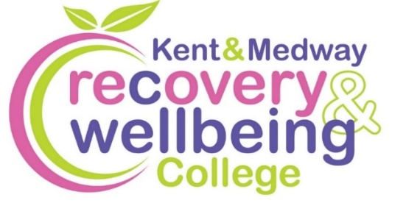
Want to improve your wellbeing?

We provide health-related educational courses for adults free of charge in supportive and accessible learning spaces. Through education, people can make sense of their experiences and learn how to take care of themselves.
Join our free courses in Ashford

Course | Date | Time | Venue
Creativity for Wellbeing – Starlight | Wed, 21 Jan | 1 to 3pm | Moat Foundation Community Suite
Student Connect | Mon, 2 Feb | 12.30 to 2.30pm | Moat Foundation Community Suite
Winter Wellbeing | Wed, 4 Feb | 12 midday to 2pm | The Limes Community Garden
Mental Health Toolkit | Wed, 11 Feb | 12 midday to 2pm | The Limes Community Garden
Discovering Your Inner Strength and Potential | Wed, 11, 18 Mar | 1 to 3pm | Moat Foundation Community Suite
Spring Wellbeing | Wed, 1 Apr | 12 midday to 2pm | The Limes Community Garden

To enrol, scan the QR code, or visit:
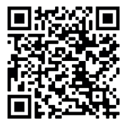
www.kentmedwaymentalhealth.nhs.uk/about-us/recovery-and-wellbeing-college/

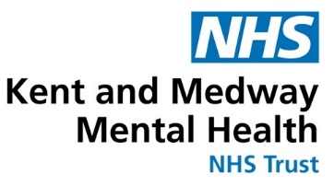
To book call 07825 859412 or email kmmh.ashfordrc@nhs.net

