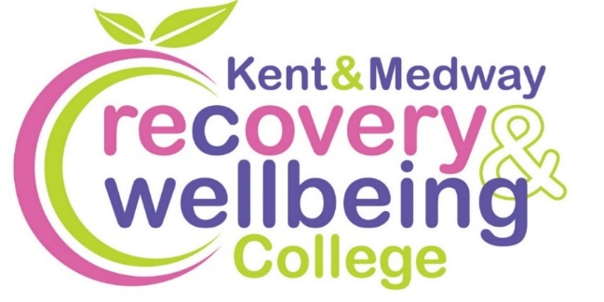
Want to improve your wellbeing?

We provide health-related educational courses for adults free of charge in supportive and accessible learning spaces. Through education, people can make sense of their experiences and learn how to take care of themselves.

Join our free courses in Canterbury
Course | Date | Time | Venue
Relax and Breathe | Tues, 20 Jan | 10.30am to 12.30pm | MS Therapy Centre
Goodbye to Clutter | Wed, 28 Jan & 4 Feb | 1.30 to 3.30pm | Spring Lane Neighbourhood Centre
Creativity for Wellbeing – Fabric coasters | Thurs, 12 Feb | 10.30am to 12.30pm | Spring Lane Neighbourhood Centre
Exploring Psychosis | Wed, 4, 11, 18, 25 Mar | 2 to 4pm | Canterbury Adult Education
Spring Wellbeing | Wed, 1 Apr | 12.30 to 2.30pm | Abbey Physic Community Garden, Faversham


To enrol, scan the QR code, or visit:
https://www.kentmedwaymentalhealth.nhs.uk/about-us/recovery-and-wellbeing-college/
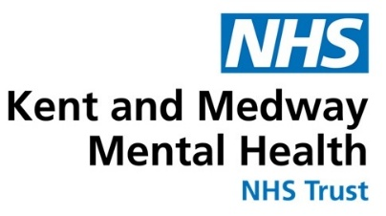
To book call 07435 778961 or email kmmh.canterburyrc@nhs.net

