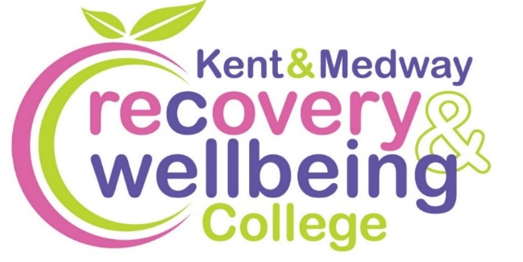
Want to improve your wellbeing?

We provide health-related educational courses for adults free of charge in supportive and accessible learning spaces. Through education, people can make sense of their experiences and learn how to take care of themselves.
Join our free courses in Medway & Swale

Course | Date | Time | Venue
How to Sleep Well | Tues, 20 Jan | 1 to 3pm | Sunlight Centre, Gillingham
Living Well on a Budget | Mon, 2 Feb | 1 to 3pm | Heather House, Sittingbourne
Wilder Wellbeing | Tues, 3, 10, 24 Feb & 3, 10, 17 Mar | 10.30am to 12.30pm | Riverside Country Park, Gillingham
Mental Health Toolkit | Mon, 9 Feb | 11am to 1pm | Sunlight Centre, Gillingham
Healing Words | Mon, 2 Mar | 1 to 3pm | Rochester Adult Education Centre
Introduction to Meditation | Thurs, 26 Mar | 1.30 to 3.30pm | Hope Street, Sheerness

To enrol, scan the QR code, or visit:

https://www.kentmedwaymentalhealth.nhs.uk/about-us/recovery-and-wellbeing-college/

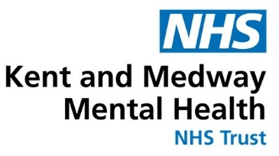
To book call 07707 152432 / 07707 152428 or email kmmh.medwayrc@nhs.net

