COMMITTEE MEETING
Meeting details
Committee: Quality Committee
Date of Meeting: Monday 15th September 2025
Title of Paper: Annual Infection Prevention and Control report
Author: Cheryl Cramer, Infection Prevention and Control Matron
Executive Director: Andy Cruickshank, Chief Nurse
Purpose of Paper
Purpose: Noting
Submission to Committee: Regulatory Requirement
Overview of Paper
This is the Annual DIPC report. The report notes good practice, challenges and the proposed work plan for coming year along with the Board Assurance Framework. KMPT are mostly compliant with the Health and Social Care Act’s (2012) Code of Practice for the NHS on the prevention and control of healthcare associated infections and related guidance.

Issues to bring to the Committee’s attention
Highlights:
- Annual IPC audit highlighted good infection control practice with an overall inpatient score of 95% and community score of 93% compliance.
- Zero cases of Clostridium difficile transferred into our services and zero MRSA bacteraemia reported.
- Continued robust management of Covid 19
- Policies updated in line with Health and Social care act changes
- Health awareness and Health promotion continued
- Updated IPC BAF
- Updated IPC Annual workplan
- Mandatory AMR training implemented
- Positive feedback from ICB compliance visit
- Continued performance despite staff shortages
- Continued performance despite organisational and team restructure

Priorities for the 2025/2026 are:

- To monitor the rates of infections for both national and local reporting requirements.
- Monitor infection prevention and control practices through scheduled audits
- Recruitment of AMS lead
- Continue to improve staff education and awareness of Infection Prevention and Control practices and hand hygiene
- Increase staff awareness of hand hygiene and PPE use
- Proactively work with Directorates to manage Infection prevention and control issues
Governance
Implications/Impact: Good IPC practice is significantly linked to patient safety
Poor IPC practice will lead to individual and group/herd risks in relation to the prevention and management of infection
Poor IPC practice has the potential to result in significant staffing shortages, which would result in a lack of workforce resource and therefore financial strain
This report is a mandated report. Good IPC practice is a requirement of the Health and Social Care Act
The DIPC report engages the Trust’s Infection prevention and control matron in ensuring that the Annual report gives an accurate reflection of progress
Risk recorded on: BAF
Risk IDs:
- 04676 – Organisational risk – Emerging infectious diseases (including covid-19 and subsequent variants)
- HS19 Blood Borne Viruses- Organisational Risk

Assurance/Oversight: Trustwide Patient Safety and Mortality review group
Trustwide Infection control group
Trust wide water safety group

1.Foreword
Kent and Medway NHS and Social Care Partnership Trust (KMPT) is committed to ensuring a robust infection prevention and control function within the Trust, supporting the delivery of high-quality healthcare and protecting the health of its patients and staff.
The Trust has a statutory responsibility to comply with the Health and Social Care Act: Code of Practice for the prevention and control of Healthcare-Associated Infection (2012). A requirement of this Act is for the Board of Directors to receive an annual report from the Director of Infection Prevention and Control. The annual report of the Infection, Prevention and Control Team (IPC) provides an overview of the activities carried out in the Trust to progress the prevention, control and management of infection from April 2024 to March 2025.

During the period 2025-2024, the trend of low rates of alert organisms and conditions has continued. There were 9 outbreaks of gastrointestinal disease affecting 41 patients and 11 staff, zero C.Diff or MRSA bacteraemia. We had 5 covid outbreaks across inpatient and community-based services, affecting 15 patients and 6 staff.

As the Director of Infection Prevention and Control (DIPC), both I and the Infection prevention and control team (IPC Team) continue to be committed to ensuring that patient safety is at the forefront of everything we do.

I commend this annual report to you and thank the infection control team for their excellent leadership of this agenda, and to the Trust for the continued focus they give to this important area.

Andy Cruikshank
Chief Nurse/DIPC

2. Executive summary

The annual report from the Director of Infection Prevention and Control (DIPC) is produced to provide information about our current progress in IPC practice and activities carried out in 2024-2025, reports on our challenges and outline our future plans.
Within 2024-2025, the IPC team maintained and supported improvement in the standards of care for our patients in relation to infections. A summary of the IPC work plan can be noted in Appendix A.
Structure, accountability and assurance
The structure for the management of the infection, prevention and control service complies with the Hygiene Code 2008.
Chief Executive

Chief Nurse/Director of Infection Prevention and Control

Deputy Director of Infection Prevention and Control

Corporate Head of Nursing & Quality

Matron for Infection prevention and Control and Physical Health

Senior Infection Prevention and Control and Physical Health Nurse
Infection Prevention and Control and Physical Health Practice Development Nurse
Senior Infection Prevention and Control and Physical Health Nurse

Microbiology Services The processing of clinical specimens is carried out via the microbiology departments within the 4 acute hospitals within Kent & Medway. As of May 2025, following the restructure of the corporate nursing teams, the organisation has allocated funding for the employment of an anti-microbial pharmacist.

The Trust wide Infection Control Group is chaired by the Deputy DIPC and meets bi-monthly with representation from all Directorates and support services, including Estates and Facilities. In addition to this, the Water Safety group meets every 4 months. These groups provide a forum for discussion, decision making and governance oversight on measures for the prevention and control of infection within the Trust. Members are expected to cascade information back to their relevant teams, ensuring that infection prevention and control is on the governance agenda for Directorates.

Infection prevention and control continues to be essential in ensuring that people who use health and social care services receive safe, effective, well-led and responsive care. Effective prevention and control must be part of everyday practice and has to be applied consistently by everyone.

The key documents and legislation that the organisation adheres to includes:
- Health and Social Care Act 2012 (Regulated Activities).
- Care Quality Commission (Registration) Regulations 2009.
- Health and Social Care Act 2008 (Regulated Activities) Regulations 2014
- CQC Fundamental Standards CQC (Registration) Regulations 2009 - Regulation 12 – Safe care and treatment
- All relevant NHSI/E / Department of Health and Social Care guidance.
- National Infection prevention and control manual

4. Reporting mechanisms
The DIPC reports to the Trust Board via the IQPR and Quality Committee. Period reports are provided to the Trust wide Patient Safety and Mortality Meeting in accordance with the work plan.

Data surveillance of all suspected or confirmed infections are reported to the IPC team from all Directorates and this is monitored through the bi-monthly Trust wide IPC group.

Infection control issues are supported by the Infection prevention and control team and Deputy DIPC. The members of the IPC Team provide infection control expertise including results of surveillance, audit and alert organism reporting to a variety of groups across the organisation.

Link champions from each ward/unit are nominated to provide ‘on the floor’ infection control advice. These staff are vital to support infection control practice.

5. Board assurance framework

The IPC team produces an assurance framework which ensures that all relevant actions are being taken in order to comply with the 10 criteria identified in The Health and Social Care Act’s (2008) Code of Practice for health and adult social care on the prevention and control of infections and related guidance (also known as the Hygiene Code). This Board assurance framework provides the Trust with a comprehensive method for the effective and focused management of the principal risks. It also provides a structure for the evidence to support the statement on internal control. Appendix B

6. Policies
In 2024-2025 the following policies were reviewed and updated in line with current legislation and guidance.

- Books, Toys, Games and Magazines Safe Use and Cleaning Policy – May 2024
- Decontamination Procedure – July 2024
- Management of Sharps Injury/Splash Incidents and Exposure to Blood Borne Viruses (BBV) Policy and Procedure – March 2025
- Aseptic Non-Touch Technique (A.N.T.T) Policy – March 2025
- Human Infestation Policy – March 2025

In addition to business as usual policies, a number of standard operating procedures (SOPS) were developed in response to Covid 19. These are reviewed at Trust Wide patient safety and mortality review group. These SOPs were continually version controlled, reviewed, updated or archived in response to rapidly changing guidance, with now only 3 remaining. See Appendix E.

7. Clinical audit and effectiveness

Trust wide Infection Prevention and Control Audit

KMPT produces an audit to monitor, develop and implement plans for reducing Health Care Acquired Infections (HCAIs), including Methicillin Resistant Staphylococcus Aureus (MRSA), Clostridioides difficile (C.diff) and other significant infections.

Once an audit is undertaken each ward/community team is provided with an action plan to complete and return to finalise the audit process. There were no issues identified for the tool this year.

Results

The results of the Trust wide IPC audit had identified that the organisation is performing well with 93% compliance for Community services and 95% for Inpatient services. This is a slight decrease from 2023-2024 with 95% and 96% respectively.

Over all the compliance was 94%, which is a decrease from 95% for 2023-2024 audit.
The full Audit report is currently being compiled.
Table 1- Overall compliance per Directorate

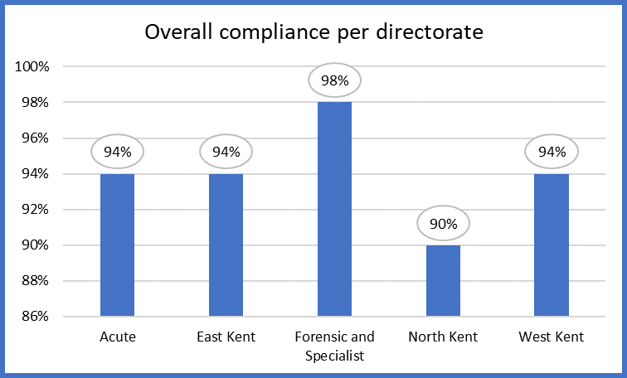

The Trust wide IPC audit proves to be beneficial in identifying actions required to ensure that all inpatient units and community teams comply with the trust’s policies and procedures and to meet the 10 elements of the Health and Social Care Act 2012.
Where anomalies are identified and improvements required, an action plan is written in collaboration with the respective ward/unit managers, Matrons and Heads of Nursing to ensure that they are resolved quickly to reduce any potential risk to our service users, staff and visitors.
Action plans for this audit, 2024/2025 will be developed by the IPC team and sent to individual areas via Matrons.

Hand hygiene audit

Units complete monthly observational hand hygiene audits.
The results of these audits are returned to the infection control team who compile the data and produce a certificate for wards to display.

Table 2- Hand hygiene results
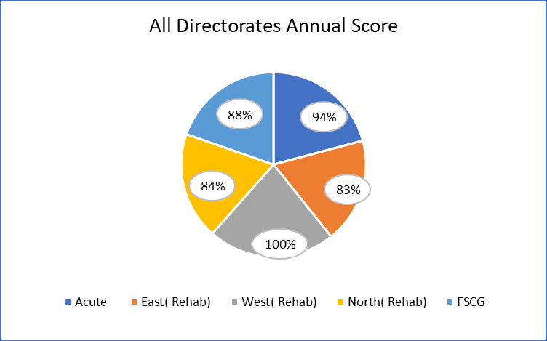

Urinary tract infection audit

Urinary tract infections are one of the most common types of infections reported which can have a detrimental effect on physical health as well as mental health. Urine infections can affect a patient’s personality and behaviour and go on to cause some acute and challenging conditions. They can result in prolonged hospital stays and increased costs for healthcare providers. Indwelling devices (catheters) are a particular risk.

There were 25 suspected and laboratory confirmed urinary tract infections identified in 2024-2025; 3 of which being Catheter associated urinary tract infections (CAUTI’s), an overall decrease compared to 72 in 2023-2024 period but an increase in CAUTI’s.

All identified urinary tract infections across Directorates were closely monitored by the infection control team and pharmacists to ensure that the treatment offered was appropriate and timely.

Trust wide Mattress Audit

Hospital mattresses can deteriorate quickly. Poor maintenance of mattresses and their covers may lead to contamination of inner surfaces.
In the 2024-2025 all beds and mattresses will be replaced trust wide (bed replacement scheme). The mattress audit will be undertaken by the moving and handling team alongside DHG going forward. In April, 18 mattresses were condemned and replaced by the moving and handling team.
Individual results of Annual Mattress audit in Appendix D.

Annual water report

The Trust continues to pursue a proactive approach to water quality management through regular temperature monitoring and flushing of little-used and sentinel outlets across its sites together with ad hoc pathogen testing. Results remain consistent with previous quarters and give no cause for concern. Our current performance figures have stabilised above 95% for the entire quarter.
Within the last quarter, the Estates Team have agreed to chair the Water Management Group moving forward and will be branded Water Safety Group in line with NHSE guidance. An updated agenda and Terms of Reference was worked during Q3 and shared with the Water Safety Group on 10th December 2024. Our latest meeting was held on 11th March 2025. We will also be drafting a Water Safety Strategy during Q1 2025-2026.
The Water Safety Group covers IPC, Estates, Facilities, Capital Projects, Hydrotherapy and Landlord reporting to capture a wider scope of information to enable trend analysis.
As Head of Estates, Lee Mitchell, will undertake the role of Responsible Person (RP Water Quality) and a total of 18 colleagues have now completed RP or CP Water Training. Recent training was a success with all colleagues able to achieve 94% and above in their recent assessments. Appointment letters will continue to be issued to colleagues during Q4.
Any water testing found to be out of scope results in remedial action and are available via a Hard FM job portal. Water quality works performance form part of the overall reactive and PPM jobs and the performance figures for the last quarter are as follows:

- January – 97%
- February – 96%
- March – 97% (as of 10th March 2025)

We have one Water Risk Assessment noted as overdue, due to a current vacant building. This will be replaced by a survey to ensure all water is safely isolated and tanks checked for stagnation. We have two Water Risk Assessments due during Q4 and both are booked in at site level.

In an ideal world the PPM performance figure would consistently be at 100% but there are inevitable factors to consider such as access issues, and paperwork delays and so the Estates Department works with the maintenance provider to ensure we consistently achieve as close to 100% as possible and the latest performance figures are satisfactory and reflect a stable platform. It should be noted that the Estates Team undertakes to audit these performance figures and will address any deviation or false claim of compliance. We have incorporated the PFI within the above compliance and it is encouraging that GFM have not impacted the overall numbers.

Incidents

Three incidents or events was raised at The Water Safety Group, dated 11th March 2025. The first was due to a 3rd party working on behalf of another Trust in our Hydro-pool, where protocol around footwear was not observed and we had to close the Hydro-pool whilst rebalancing.
The other two were similar in nature and created airlocks in the system, following a PPM check and clean of the water tanks, where the engineer left site with the water still isolated. This were treated as minor loss of control, with full flush and pasteurization of the systems.
A review of our internal incident reporting ‘InPhase’ found no recorded incidents of note.
Water testing
No further testing has taken place during Q4, other than are regular Hydro-pool Maintenance.

Capital Projects:
None in progress

Kent and Medway Integrated Care Board Infection Prevention and Control (KMICB) Surveillance Visit
The NHS KMICB IPC team developed an IPC Surveillance Programme which is aimed at supporting all providers to meet the required IPC standards. This involves an annual surveillance visit and feedback. This occurred on 6th December 2024.
The structure of the visit is based on the 10 criteria set out in the IPC code of practice and will also provide assurance that providers are meeting contractual obligations with the KMICB.
The full report can be found in appendix F.
8. Antimicrobial prescribing and management
Effective antimicrobial stewardship within hospitals and community settings makes an important contribution to the control and prevention of Clostridioides difficile (C.diff), associated diarrhoea and other health care associated infections.

Monitoring compliance and effectiveness of KMPT Antimicrobial policy includes the monitoring and review of all antimicrobial prescriptions across all inpatient units by the infection control team. Prescriptions are checked against the KMPT antimicrobial stewardship policy and supported by the pharmacy team. This information is collated onto a database and any concerns regarding antimicrobial prescribing is addressed between the IPC Team, ward staff, the prescriber and pharmacy staff. In addition, broad spectrum antibiotics are not a stock item on the wards. All broad-spectrum antibiotic requests made to Lloyd’s pharmacy are highlighted to the KMPT pharmacists.

An options paper has been developed to employ an Antimicrobial pharmacist which has bee agreed.

9. Training and education
Training remains high priority on the IPC team’s agenda, providing face to face training for staff or producing the training packages used for core training or e-learning. During the period from the 1 April 2024 to the 31 March 2025 staff were trained in infection prevention and control through a variety of training methods which include:

E-Learning packages | Student nurse infection control training
Ad-hoc drop in | Light box hand hygiene training for in-patient and community teams
Face to face taught sessions | Link nurse three monthly updates
Preceptor training | Outbreak management
Link nurse training and development | Learning from RCA’s

The following charts show compliance with mandatory training across the organisation.
Table 3- Trust Overall Infection Control training compliance
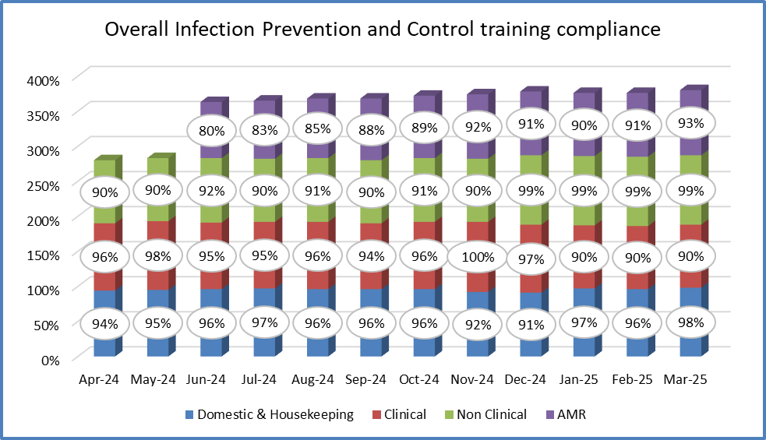
Learning and Development send monthly e-mail reminders to those who are out of date and those who are due to expire within the next four months.

In February 2024 we implanted mandatory Antimicrobial resistance training for all those who prescribe, dispense and administer antimicrobials. There is a 75% completion target set across all directorates.

Table 4- AMR training compliance

The IPC team analyse these figures quarterly for the Board report and any areas below target are contacted, either via ward managers or matrons, to inform them of this shortfall.

10. Link nurse practitioners
All inpatient units and community teams should have an identified Link Champion in place working in partnership with the senior infection control nurse to provide IPC support to their clinical areas.

A link Champion training programme facilitated by the Infection Prevention and Control team is undertaken which enables the link practitioner to train and support staff within their own clinical areas. These sessions provide the skills required to facilitate this role successfully. Link champion update meetings are held on a 3 monthly basis. They act as a communication tool to impart information from board to ward and also offer network opportunities for staff.

11. Needlestick/sharps/splash injuries
Needlestick injuries occur when a needle or other sharp implement penetrates the skin. If the needle or sharp instrument is contaminated with blood or other bodily fluids, there is the potential risk of transmission of infection. Staff experiencing this type of injury risk acquiring Hepatitis B, Hepatitis C and Human Immunodeficiency Virus (HIV).

There were 5 reported cases of sharps injury this year which is a slight decrease from the previous year where 9 cases were reported. In all these instances, safety devices were used and sharps injury policy followed.

12. Outbreaks / periods of increased incidence
Outbreaks
Nil outbreaks of notifiable diseases. Covid outbreaks are discussed later in report.

Outbreaks of gastrointestinal illness unknown cause

Date | Ward | No. of patients | No, of staff
April 2024 | Orchards | 5 | 0
April 2024 | Fern | 4 | 1
May 2024 | Heather | 2 | 0
May 2024 | Fern | 2 | 1
May 2024 | Ruby | 9 | 4
November 2024 | Ruby | 4 | 0
December 2024 | Bluebell | 3 | 1
February 2025 | Woodchurch | 4 | 0
February 2025 | Sevenscore | 8 | 4

Surveillance

All infections are reported to the infection control team. Notable infections include:
• 1 Candidozyma Auris (Candida Auris) – transferred from London hospital

13. MRSA screening
The Department of Health and Social Care (DHSC) requires all NHS trusts to record methicillin-resistant staphylococcus aureus (MRSA) screening data for elective and emergency admissions. Within mental health, there are no elective patients; therefore, the DHSC has identified incidents of greater clinical risk for admissions to Mental Health providers.

The screening criterion for new admissions within KMPT is as follows:

- service users who are admitted to mental health wards or units having had surgery or any surgical procedures
- any service user who was transferred from an acute trust
- service users who misuse drug intravenously
- service users who self-harm
- service users with chronic wounds, e.g. leg ulcers or have a catheter or any other indwelling device.

MRSA screening figures

MRSA screening figures are discussed at each Trust wide Infection Prevention Control Group meeting with actions to Directorate representatives in those areas that have reduced levels of screening.

The target for MRSA screening is 100%, but due to the nature of our service users’ mental health presentation, people may refuse the swabbing procedure at times. This is monitored via the Infection Prevention and Control team.

Table 5- MRSA screening compliance

MRSA bacteraemia
There were no reported cases of MRSA bacteraemia (MRSA bloodstream infection) during this time period. The last case reported was October 2011.

14. Sepsis

Sepsis is a medical emergency with a high mortality rate. It is often under-recognised and frequently under-treated. The successful management of sepsis requires a high index of suspicion and early recognition. Patients cared for within their own home or within inpatient settings must be identified and treatment initiated quickly to improve outcomes.

Sepsis awareness is promoted in the organisation by annual training updates for clinical staff within Cardio Pulmonary Resuscitation (CPR) and Immediate life support (ILS) training in conjunction with the Sepsis screening tool on our NEWS2 (National Early Warning Score) charts. There is also a sepsis policy available for reference on the Trust’s intranet.

There were 3 reported incidences of suspected sepsis within the Trust for 2024-2025. This is the same as the 2023-2024 period which indicates an increased in awareness. All patients were identified using NEWS 2 and transferred in a timely manner to the local Acute hospital for management.

15. Decontamination

The IPC team work closely with the Medical Devices Co-ordinator to ensure that sufficient guidance is available to staff on the safe methods of decontamination for medical devices.
This is to protect all staff and service users from the transmission of micro-organisms from medical devices, associated consumables and materials used in the physical assessment, treatment, diagnosis and care of our service users.

Cleaning report summary

Many sites are consistently achieving high scores and the overall standards across KMPT are high. There are still some Estates matters that can decrease the scores and where there have been shortfalls in staffing, this has been noticeable and has also affected the scores. Action plans continue to be put into place when there are sites that do not reach their target scores.
Bedroom audits across the Trusts are now taking place and there is improvement with cleanliness. Throughout 2024-25 this will continue to be monitored and scores reported to ensure that we are maintaining cleaning standards in all areas across the Trust.

Full cleaning report can be found in Appendix C

16. Seasonal influenza campaign

The CQUIN target for the 2024/2025 Flu campaign was set at 90%. Uptake has been challenging this year, and staff report issues such as concerns around side effects and not liking needles as well as allergies or medical concerns. InFLUencers have worked remarkably hard to achieve 40% CQUIN. A decrease from the 2023/2024. The table below shows percentages of staff vaccinated per Directorate.

Table 6- Total staff vaccinated 2024-2025

Covid19 Pandemic

Coronavirus disease (COVID-19) is an infectious disease caused by severe acute respiratory syndrome coronavirus 2 (SARS-CoV-2).

The World Health Organisation declared Covid 19 a pandemic on 11th March 2020. The IPC team provide expert advice and guidance for the organisation, in conjunction with Department of health guidelines, and develop and review many standard operating procedures to provide guidance to the Trust. They liaise directly with colleagues across the Kent and Medway network and the UK as a whole.
The table below shows confirmed cases of Covid 19 in both our inpatient and community caseloads. We no longer record suspected Covid19 cases and only record positive cases in relation to an outbreak.
Table 7- Confirmed Covid-19 cases

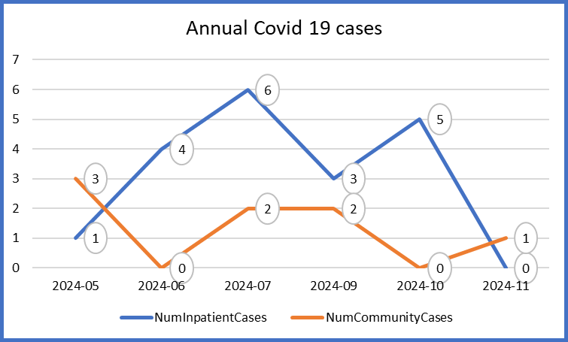

Covid 19 swabbing is now only required for those who are eligible for Covid 19 treatment.

All patients are swabbed and isolated following government recommended timeframes, these have changed a number of times during 2024-2025 and these have been implemented in a timely manner.

In response to the pandemic, KMPT developed a number of systems and processes to manage the Covid 19 pandemic. These were established in conjunction with the National Major incident level 4 response led by NHS England and Public Health England. Within the Trust a range of standard operating procedures were developed and approved. The IPC team worked collaboratively with the information and performance team to identify suspected and positive Covid patients via RiO, KMPT’s web-based clinical system. Many SOPs have been archived as we move more to pre-pandemic working.

Outbreaks are defined as two or more cases on a ward/unit of the same type related in time and place. KMPT saw 5 Covid outbreaks across inpatient and community-based services, affecting 15 patients and 6 staff. These were monitored closely by the IPC team who provided support and guidance to manage the outbreak with regards to ventilation, PPE use and increased testing for all staff and patients. None of these patients were eligible for Covid 19 treatments and swabbing guidance had to be reiterated to matrons, ward managers and ward staff.

These outbreaks are investigated using the PSIRF process. Any actions identified were completed and lessons learned communicated back to the ward.

Fit testing

Due to the publication of the New IPC Manual in April 2022 and revised AGP list; KMPT no longer undertakes any AGP’s. The IPC team hold a list of registered Fit testers, should the need arise for additional fit testing. The IPC team continue to hold sessions for fit testing. We are awaiting the NHSE resilience guidance for mental health.

17. Conclusion

Within 2024-2025, the IPC team maintained and improved the standards of care for our patients in relation to infections despite significant staff shortages.

Auditing current infection prevention and control systems, processes and practice ensures a continual progression of quality improvement. This results in change to clinical practice and makes certain that all staff are trained to a high standard. This has been achieved by working collaboratively with internal and external stakeholders across the whole system.
Operational teams across the organisation are working collaboratively to provide and disseminate information and offer support to all staff in regards to infection control measures.
The infection control team continue to support monitoring for infections across the Trust. KMPT staff are to be commended for their resilience and care for our clients.

Appendix A- Infection Prevention and control Team work Plan 2025-2026

Appendix B- KMPT board assurance framework 2025/2026

Appendix C- Cleaning report

Appendix D- Mattress audit

Appendix E- COVID-19 Standard Operating Procedures
- Management of patients with symptoms of COVID 19 on an inpatient ward
- Staff Testing SOP (previously Test and Trace SOP)
- COVID medicines delivery unit (CMDU) Treatment referral form

Appendix F- Kent and Medway Integrated Care Board Infection Prevention and Control (KMICB) Surveillance Visit

