Kent and Medway Mental Health NHS Trust

Equality, Diversity and Inclusion

Annual Report

2024-25

ENTS
Foreword
We are pleased to present Kent and Medway Mental Health NHS Trust’s (KMMH) first Annual Equality Report, covering April 2024 to June 2025. This report marks an important milestone in our commitment to equality, diversity, and inclusion (EDI) in our workplace, providing a unified overview of the progress we’ve made over the past year.
We believe that nurturing a diverse and inclusive workforce is essential to providing outstanding care and ensuring a positive experience for all who interact with our services. Over the past year, we have focused on fostering an environment where staff across our workforce feel valued, supported, and empowered, in the knowledge that this experience ultimately passes to our patients.
This report provides a detailed examination of our Gender Pay Gap, performance against Workforce Equality Standards, and progress in line with NHS England’s Equality, Diversity, and Inclusion High Impact Actions (HIA). Alongside these, we highlight a variety of initiatives linked to our six strategic priorities from our EDI plan, aimed at strengthening inclusivity across KMMH.
We recognise that achieving meaningful equality is not just about meeting targets — it requires sustained effort, reflection, and action that truly addresses the diverse experiences of our workforce and the communities we serve. Whilst reflecting on our successes, this report also outlines where we must continue to improve.
We are grateful to the many colleagues, patients and community partners who have supported our ongoing efforts to build a fairer and more inclusive healthcare system, and look forward to seeing further positive change over the coming months and years.

Contents

Introduction 4
Welcome to our annual equality report 2024-25 4
Equality Diversity and Inclusion (EDI) Plan 5
Race 8
Key findings: Race 9
Disability 19
Key findings: Disability 19
Gender/sex 29
Key findings: Gender (sex) 29
Religion and belief 37
Key findings: Religion and belief 37
Sexual orientation 43
Key findings: Sexual orientation 43
Age 48
Key findings: Age 48
Neurodiversity 52
Equality Delivery System 2022 (EDS22) 53
Summary of Actions for Equality, Diversity, and Inclusion 2025-2027 54

Introduction

Welcome to our annual equality report 2024-25
This report showcases the progress we’ve made so far and highlights the areas where continued effort is essential to further equality. It demonstrates our unwavering dedication to attracting a broad spectrum of talent, cultivating an inclusive workplace, and nurturing an environment where both staff and patients can flourish. By placing fairness, wellbeing, and safety at the core of our operations, we strive to build a vibrant culture that drives productivity, loyalty, and sustainable success for everyone involved.
Our Equality, Diversity and Inclusion (EDI) plan reinforces our commitment to being an inclusive, diverse, fair, and equitable organisation, and plays a vital role in delivering our Trust’s strategic priorities.
The report is organised into eight key sections aligned to our focus on: age, disability, gender, race, religion and belief, sex, sexual orientation, and organisational inclusion.
Each section begins with a summary of our accomplishments in promoting equality and building positive relationships. It presents core findings, including data on workforce representation and recruitment trends and outlines the measures we’ve taken to combat discrimination and tackle harassment.
This report highlights what we have achieved over the last 12 months and where we need to continue progressing towards equality in our mission of providing safe, compassionate and high-quality care aligned with the NHS England High Impact Actions.
We have aligned our EDI strategy with the organisational priority of creating a great workplace, fostering engaged and capable staff who embody our values, (Caring, Inclusive, Curious, Confident) as part of our Culture, Identity and Staff Experience programme (CISE)
The data in this report and for the mandated submissions is taken from electronic staff records, staff survey, gender pay gap and our WRES and WDES findings. Patient data is reported separately.
This report evidences compliance with our Public Sector Equality Duty (PSED) within the Equality Act 2010, our duty to publish gender pay gap information and our mandated obligations to publish information relating to the workforce race equality standard (and the workforce disability equality standard.

Equality Diversity and Inclusion (EDI) Plan

Our EDI programme is to create a more equitable, diverse and inclusive KMMH, so that no matter where people come from, what they look like or how they identify they will have a voice, be accepted, safe and cared for. Fostering a culture of belonging and understanding among our people, patients and communities to eliminate disparities, empower diverse voices and promote health equity for all.
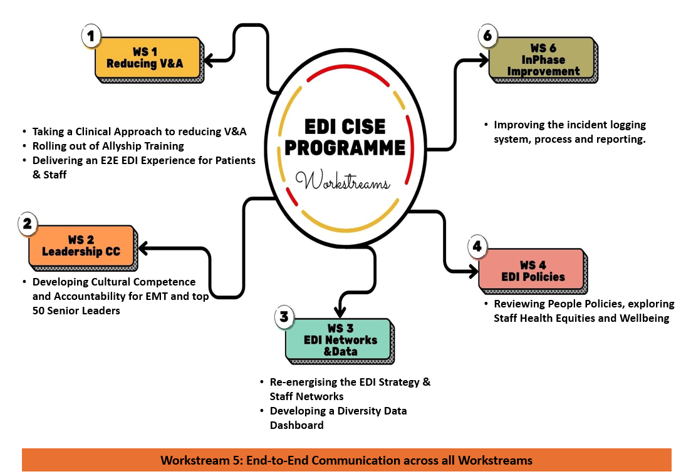

Focus Area 1 – Reducing incidents related to racism, violence and aggression on inpatient wards.
Focus Area 2 – Improving Leadership Accountability through cultural competence.
Focus Area 3 – Enhancing the EDI Strategy through workforce engagement and data.
Focus Area 4 – Review and enhance all People Policies to make sure they reflect the needs of the workforce and improve staff health equities and wellbeing.
Focus Area 5 – Connecting the workforce through effective communications and engagement
Focus Area 6 – Improving the end-to-end incident logging system and process (InPhase).
Focus Area | Progress/update
- Reducing violence and aggression. | This workstream integrates four coordinated sub-areas aimed at tackling racism, violence, and aggression experienced by both staff and patients. Each sub-workstream supports the shared goal of reducing harm, improving morale, and promoting high-quality, inclusive care.  Clinical Approach to Reducing Violence & Aggression  Led by the Chief Nurse Officer (CNO), this sub-workstream focussed on improving the clinical response to incidents of violence and aggression. It promoted early risk identification, improved de-escalation techniques, and consistent clinical pathways.  Allyship Training and Active Ally Workshop Feedback  This sub-workstream delivers practical training to develop Allyship Champions through a Train-the-Trainer model and to embed active bystander principles into the working culture. So far, 14 wards have completed the training, with 322 staff trained across 13 sessions. The programme continues to grow, embedding allyship in everyday behaviours and strengthening team culture.  EDI Experience (E2E) Pathway for Patients and Staff  This live pilot in the Acute Team tests a step-by-step pathway to improve how patients and staff experience equality, diversity, and inclusion in care and service access.  Respect and Safety Behavioural Accountability Process (RSBAP)  This new structured process addresses offensive, discriminatory, or aggressive behaviour from patients. It includes escalation letters, MDT assessments, review panels, and, if needed, legal action. Letters are triggered via InPhase and authorised by the Chief Nurse Officer.
2. Improving leadership accountability through cultural competence | EDI thread embedded into Leadership and management Programmes:  - Senior leadership – Doing Well Together programme; Lead Self, Lead Teams, Lead Organisation/System – each generate practical applications in nurturing diversity, equity and inclusion.  - All facilitated courses are designed with the objective of encouraging participants to view topics through a diverse and inclusive lens.
3. Enhancing the EDI Strategy through workforce engagement and data | - Staff Networks now using standardised agendas:  - Alignment with Trust priorities  - Emerging themes  - Learning and education  All network Terms of References have been refreshed in line with the Trusts Culture, Identity and Staff Experience vision.  - Dashboard in development:  - Data cleansed exercise has taken place and will be a yearly exercise with frequent campaigns for staff to update their diversity details.  - HRBPs, managers and staff to will be able access to reports from Dashboard via BI reports – the dashboard is currently being developed.
4. Review and enhance all people policies to make sure they reflect the needs of the workforce and improve staff health equities and wellbeing, | Working group has been set up to review workforce policies.  Equality Impact Assessment Consultation Group has been formed as a one stop group for EQIA authors to consult on policies, strategies, projects etc to identify any impact (negative/positive), group consists of either chairs or members from staff networks and other key stakeholders.  Psychological support is being piloted for staff (victims) of violence and aggression in the workplace, as well as
5. Connecting with the workforce through effective communications and engagement | Work is currently taking place across the trust to communicate the trusts new identity, the use of staff room is being utilised to promote updates, videos, EDI listening events and the EDI podcast.  Trust messages around respect, anti-discrimination is being communicated, with work being scoped on posters and wall decals.  Further work is due to be commence on other ways of communicating information to staff.
6. Improving the end-to-end incident logging system and process [InPhase] | A range of initiatives have been implemented to improve incident reporting and monitoring. Staff are encouraged to report all incidents, supported by the principle of “if in doubt, report it.”  Bespoke reporting tools have been developed, including dashboards for monitoring incidents such as violence and aggression, with analysis by factors such as ethnicity.  Training sessions are regularly delivered to empower staff to report incidents confidently, while publications like the InPhase Bulletin reinforce this message.  System improvements include clearer guidance and help prompts on reporting forms, alongside efforts to minimise unnecessary questions to reduce reporting barriers.  While most elements of the form are controlled nationally through NHS England’s LFPSE framework, local efforts have focused on simplifying and clarifying requirements.

Race
The proportion of our Black, Asian, Minority Ethnic (BAME) colleagues has grown over years across KMMH. Overall BAME representation: 30% (1165 staff) – Exceeding the 22% target. Year-on-year growth:
2021/22: 23.5%
2022/23: 25%
2023/24: 28%
2024/25: 30%

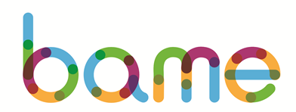
KMMH’s Global Majority Network has brought people together from different backgrounds committed to valuing individuality, supporting inclusion and promoting diversity. Key achievements include:
Total Members: 247
Key Achievements and Activities:
- Addressing Racism: Continued efforts to highlight the impact of racism in the workplace and raise awareness through staff engagement and advocacy.
- Recruitment Review: Contributed to reviews of recruitment processes to identify and challenge bias and barriers.
- Drop-In Sessions: Monthly staff drop-ins to provide peer support and safe space discussions.
- Hosting Black History Month with Key guest speakers and a celebration of black African and black Caribbean cultures with inspirational stories, food and music.
- Commemorating South Asian Heritage Month with a thought-provoking podcast hosted by Yasmin Damree-Ralph with guest Priti Joshi, Lead Social Worker and Systemic Practitioner (Perinatal services), highlighting her experiences growing up in Indian and living as a South Asian female in the UK.

Key findings: Race
Workforce ethnicity representation (WRES 1)
The number of BAME people in the workforce at 31 March 2025 was 1165, or 30% of the workforce overall. The Trust’s BAME workforce has grown by over 6.5% over the past four years.

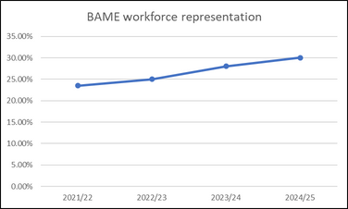

Workforce Race Equality Standard (WRES) Analysis: Clinical and Non-Clinical Staff (2024/2025)
This section provides an analysis of workforce ethnicity data for clinical and non-clinical roles across pay bands for 2024/2025. The data offers insight into representation of White, BAME, and Unknown ethnic groups across all levels, highlighting trends and potential areas for action.
Non-Clinical Staff
Non-clinical roles show higher White representation at all pay bands, with BAME representation significantly lower as bandings increase.
- Representation steadily declines with each higher band.
- From Band 5 upwards, BAME representation ranges from 0.3% to 0.07%, indicating a drop-off in diversity in more senior non-clinical roles.
- At Band 9 and VSM, BAME representation is small.
There is a clear underrepresentation of BAME staff in higher non-clinical pay bands, suggesting barriers to progression or limited opportunities for advancement.
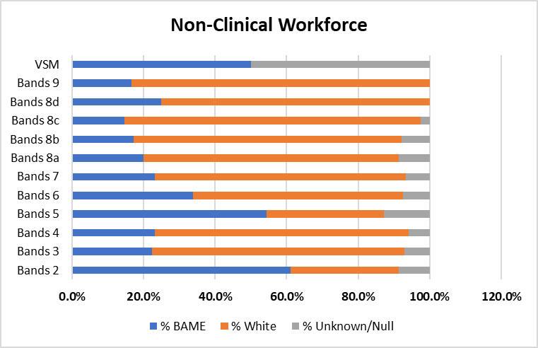

Clinical Staff
BAME representation is consistently higher in clinical roles than in non-clinical ones, especially in the middle bands and medical grades.
- There is a strong BAME presence, peaking at Band 5 (4.7%) and Band 2 (4.1%).
- BAME representation at Band 6 is 6.0%, indicating continued diversity into mid-band levels.
- However, representation drops to 2.2% at Band 7.
- There is a reduction in BAME representation in the higher banding e.g., 0.7% at 8A, falling to 0.05% at 8D, indicating a diversity gap at senior clinical management levels.

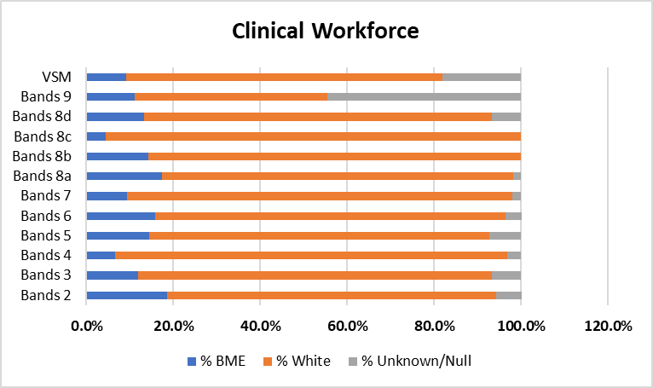

Consultant and Medical Roles:
Staff Group | BAME | White
Consultants | 58.76% | 36.08%
Senior Medical Managers* | 100% | 0%
Non-Consultant Career Grades | 82.61% | 7.25%
Trainee Grades | 66.67% | 31.37%
Other Medical and Dental | 0% | 100%
*Small numbers should be noted (only 2 staff in each category)
BAME staff make up 67.58% of the Medical & Dental workforce, with White staff at 26.48% and 5.94% unknown.
- High BAME representation overall, especially in non-consultant and trainee roles.
- BAME representation declines at consultant level.
- All senior medical managers are BAME
- White staff are more proportionally represented in consultant and trainee positions compared to non-consultant grades.

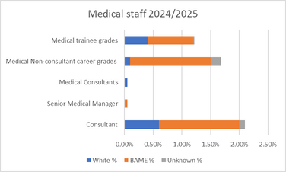

BAME shortlisting-to-appointment likelihood (WRES 2)
In 2024-25, 106 individuals from a BAME background and 86 white individuals were appointed. White applicants were 1.18 times more likely to be appointed from shortlisting compared to those from a BAME background.
However, the data represents a positive improvement of 1.4 percentage points from the previous year, when white individuals were 2.58 times more likely to be appointed.
While KMMH has made strides in improving BAME representation across the workforce, this data reveals there is still a disparity at the final selection stage of recruitment. A relative likelihood ratio above 1.0 indicates that white candidates are considerably more likely to progress from shortlisting to appointment compared to BAME counterparts. This may reflect systemic barriers or unconscious bias during the interview and selection process.
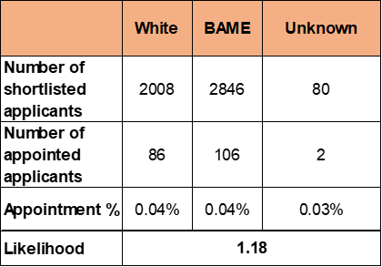

Formal disciplinary likelihood by BAME (WRES 3)
The relative likelihood of BAME staff entering a formal disciplinary process compared to white staff is 2.62. This does signal disproportionality in how disciplinary cases are initiated, while the overall number of disciplinary actions is low, the imbalance, particularly when the benchmark for fairness is a ratio of 1.0.
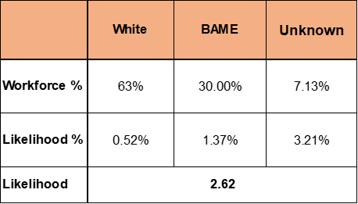

Non-mandatory training (WRES 4)
BAME staff are more likely to access non-mandatory training and CPD than white staff, with a relative likelihood of 0.86 for white staff compared to BAME staff. This suggests positive progress in ensuring equitable access to professional development opportunities across BAME groups.
The data highlights that KMMH is performing well in facilitating access to non-mandatory learning for BAME staff. This trend reflects efforts made to promote inclusive development and could strengthen workforce diversity in future leadership pipelines.
However, while accessing rates are positive, it is vital that this engagement translates into measurable outcomes, such as confidence in progression, promotions and improved survey feedback regarding equal opportunities.
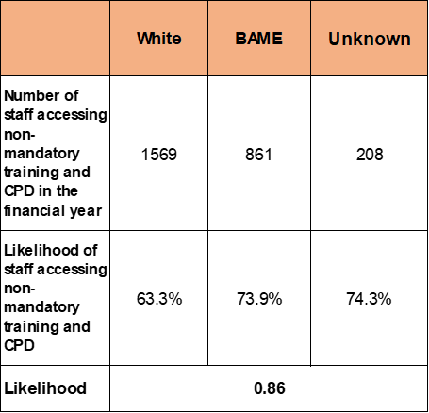

Harassment, bullying or abuse by ethnicity (WRES 5-6)
Staff experiencing harassment, bullying or abuse from patients, relatives or the public in the last 12 months.
The data shows the percentage of White and BAME staff who reported experiencing harassment, bullying, or abuse from patients, relatives, or the public across four consecutive staff surveys (2021 to 2024). There is a sharp increase in reports from BAME staff in 2024, rising to 42.7%, up from 35.2% in 2023, which is a 7.5 percentage point increase. There was also an increase in reports from White staff in 2024, but this was more modest (27.1% from 25.3%).
The gap between White and BAME staff experiences has widened in 2024, indicating persistent and worsening disparities in the experiences of abuse from the public.
The increase in BAME responses (from 400 to 491) strengthens the data’s reliability, though it also highlights that a larger proportion of BAME staff are reporting negative experiences.
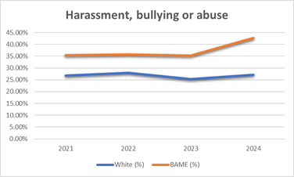

Staff experiencing harassment, bullying or abuse from staff in the last 12 months
In the latest staff survey, 19.4% of BAME staff reported experiencing harassment, bullying, or abuse from other staff within the past 12 months. This is higher than the proportion of White staff, although represents a slight reduction of 0.4 percentage points compared to the previous year and remains below the national average for BAME staff, which stands at 20.9%.
Notably, the overall proportion of staff (both White and BAME) reporting such experiences has not significantly improved over time, suggesting that workplace culture challenges persist.
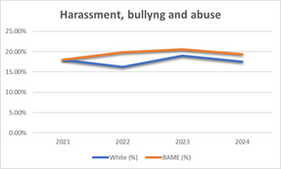

Percentage believing that Trust provides equal opportunities for career progression or promotion
The proportion of BAME staff reporting that the Trust provides equal opportunities for career progression or promotion improved from 47.3% in 2023 to 50.6% in 2024, compared with a moderate deterioration for White staff.
BAME staff consistently report lower agreement that the trust offers equal opportunities than White staff. The gap in perception between White and BAME staff peaked in 2023 (13.4%) and in 2024, the gap reduced significantly to 7.8%, indicating some positive progress toward equity, possibly due to targeted interventions or awareness efforts.
The reduction in the ethnicity gap in 2024 is promising, but continued efforts are needed to sustain and improve this trend.
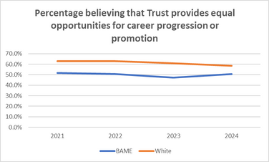

Staff work discrimination by ethnicity (WRES 8)
BAME staff have consistently higher levels of reported discrimination than white colleagues across all years. The data shows this peaked in 2023 at 13.7%, the highest across the four-year period. However, there is an improvement in 2024 (10.2%), indicating positive movement, though still higher than 2021 levels.
BAME staff report approximately twice the rate of discrimination as White staff in most years. However, like for opportunities for career progression, the gap between BAME and White staff was largest in 2023 (6.3 percentage points), and encouragingly, narrowed to 3.3 percentage points in 2024. This suggests that EDI interventions may be starting to take effect, but continued efforts are necessary.

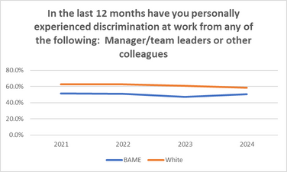

Board membership ethnicity (WRES 9)
White individuals make up 84.6% of voting board members, while constituting 67.2% of the overall workforce. This is a 17.4 percentage point overrepresentation at the voting board level.
BAME individuals account for 15.4% of voting board members, compared to 30% of the workforce. This is a 12.8 percentage point underrepresentation at board level.
While 200 staff (5.2%) have unknown ethnicity, 0% of voting board members are recorded as Unknown. This suggests more complete ethnicity data is recorded at senior levels than across the wider workforce.
Despite one BAME voting board member, BAME staff remain significantly underrepresented at senior leadership level compared to their workforce presence. Whereas, White individuals are overrepresented on the voting board, which may reinforce perceptions of inequality in access to leadership roles.
Lack of representative leadership can impact BAME staff morale, engagement, and confidence in the organisation’s commitment to inclusion. It also limits the presence of diverse voices in strategic decision-making, which can affect organisational culture and service delivery
Next steps for race equality 2025-27
Talent development
- Develop progression pathways
- Explore mentoring and leadership programmes
- Ensure inclusive recruitment and promotion processes
- Hold career conversations with BAME staff
- Link appraisals to succession planning
- Monitor survey outcomes on fairness
Recruitment Outcomes
- Analyse shortlisting-to-appointment gaps
- Implement diverse recruitment panels
Harassment, Bullying & Abuse, Discrimination
- Strengthen early resolution
- Train managers in restorative and inclusive practice
- Enhance violence and aggression initiatives
- Improve safe reporting systems
- Introduce restorative approaches to conflict
Leadership Representation
- Explore introduction of a BAME shadow board
- Explore reverse mentoring
- Build BAME succession pipelines for senior roles

Disability
KMMH data shows a representation of disabled staff across KMMH has increased to 7.8% a slight increase on the 2023/2024 figure of 7.69%. In accordance with NHS England’s WDES data, the national average of disability representation in the NHS is 4.9%.
2022/23: 7.33%
2023/24: 7.69%
2024/25: 7.8%

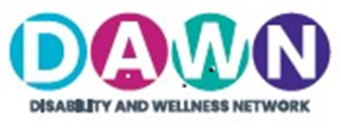
KMMH’s Disability and Wellness Network (DAWN) has brought disabled staff together, committed to valuing individuality, supporting inclusion and promoting diversity. Key achievements include:
Total Members: 74
Key Achievements and Activities:
- Addressing Disability: Continued efforts to highlight the impact in the workplace and raise awareness through staff engagement and advocacy.
- Drop-In Sessions: Monthly staff drop-ins to provide peer support and safe space discussions.
KMMH has continued to advance disability equality and make reasonable adjustments for disabled people in the workplaces as well as amplify the voices and experiences of our disabled and neurodivergent colleagues.
Key achievements include:
- Establishing a centralised reasonable adjustments process
- Produced a health and wellbeing passport to support conversations about their disabilities and/or neurodiversity
This section provides an analysis of workforce disability equality data (WDES) for clinical and non-clinical roles across pay bands for 2024/2025. The data offers insight into representation of Disabled, Non-disabled, and Not declared staff across all levels, highlighting trends and potential areas for action.

Key findings: Disability

Workforce disability representation (WDES 1)
The proportion of staff who have recorded a disability is currently 7.8%, which is an increase from 7.69% the previous year. However, the national staff survey indicates 32.7% staff have a disability, which is, again, an increase from 30.6% the previous year. This highlights a gap in KMMH’s ability to identify staff with a disability, which needs to be addressed in order to best meet the needs of this significant part of the workforce.
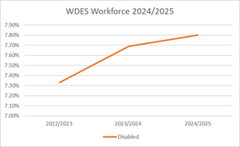

Non-Clinical Staff
Most non-clinical staff identify as non-disabled, with disabled representation varying widely across bands.
- Highest representation: Band 7 (14.6%) and Band 8c (13.6%) show the strongest disabled staff presence.
- Lowest representation: Bands 9, and VSM have 0% declared disabled staff.
- Unknown rates: Very high in senior roles – 44.4% in Band 9 and 73.3% in VSM, limiting data reliability.
- Band 2 Disabled staff are only 3.1%, suggesting potential barriers to recruitment or disclosure at lower levels.
While there is positive mid-band representation, disabled staff are absent from senior leadership and underrepresented at entry levels, with high “unknown” rates at the top masking the true picture.
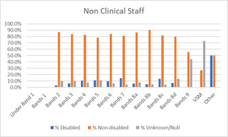
Clinical Staff
The majority of clinical staff across all bands identify as non-disabled (generally 73–83%). Disabled staff representation varies between 2.6% and 12.5%, with no declared disabled staff in Band 9 or VSM. Unknown/null rates remain high in some areas, particularly Band 5 (28.7%), Band 6 (18.1%), and VSM (100%).
- Distribution of disabled staff is fairly equal across pay bands.
- Of the lower banded posts, Band 2 has the lowest representation of disabled staff at 2.62%. Bands 3 and 4 show stronger representation (10.6% and 7.9%) with relatively low unknown rates (~9–11%).
- Disabled staff representation is marginally more consistent amongst the middle pay bands, ranging from 7.9% to 10.7%). Band 5 is notable for its very high unknown rate (28.7%), which may mask true representation.
- Band 7 has one of the highest proportions of disabled staff at 10.7% with other senior bands (8a–8d) being broadly consistent.
- There are no staff who have disclosed disability in Band 9 or VSM roles. Band 9 has a 16.7% unknown rate, and VSM is entirely 100% unknown, making representation at the most senior levels unclear.
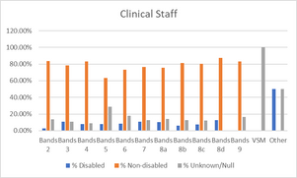
Shortlisting-to-appointment for staff with disabilities (WDES 2)
The data for 2024/2025 shows that disabled applicants made up 9.8% of shortlisted candidates (493 out of 5,009). At the appointment stage, 20 disabled applicants were successful, representing a 4.05% appointment rate. This compares with a 3.66% appointment rate for non-disabled applicants and 6.20% for those who did not state their disability status.
The likelihood ratio for appointment between disabled and non-disabled applicants was 0.92, which is close to parity (1.0). This indicates that disabled applicants were appointed at a rate broadly comparable to, and slightly higher than, their non-disabled counterparts.
Overall, the data suggests that disabled applicants are progressing through the recruitment process fairly and that there is no evidence of disadvantage at either the shortlisting or appointment stages.
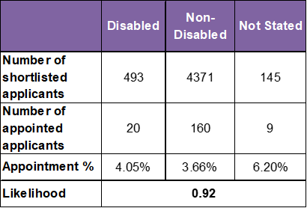
Formal capability likelihood for staff with disabilities (WDES 3)
An analysis of the 2024-2025 data of staff entering a formal capability process shows that 1 disabled staff member and 21 non-disabled staff members were subject to the procedure during the reporting period (for WDES the reporting period was a two-year period - April 2023-March 2025). This represents 0.33% of disabled staff compared with 0.70% of non-disabled staff. No cases across either group were related to ill health.
The likelihood ratio between disabled and non-disabled staff is 0.46, meaning that disabled staff are less than half as likely to enter the formal capability process as their non-disabled colleagues.
Overall, this data indicates that disabled staff are not disproportionately involved in formal capability processes. In fact, they appear less likely to be involved, which is a positive outcome from an EDI perspective. Continued monitoring will help to ensure that this trend remains consistent and that no hidden barriers emerge over time
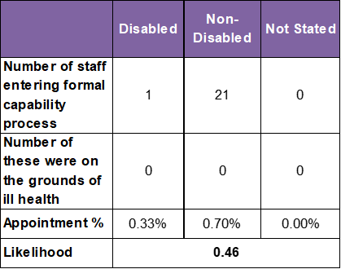

Harassment, bullying or abuse for staff with disabilities (WDES 4a-4d)
Staff experiencing harassment, bullying or abuse from patients, relatives or the public in the last 12 months. ( WDES 4a)
The 2024 staff survey results indicate that disabled staff consistently report higher levels of harassment, bullying or abuse from patients, relatives or the public compared to their non-disabled colleagues.
For disabled staff, there was a positive downward trend between 2021 and 2023 (from 33.7% to 30.6%), but this progress reversed in 2024 with a rise to 32.7%. This is above the national average of 26.6%. A more exaggerated increase however was seen for non-disabled staff.
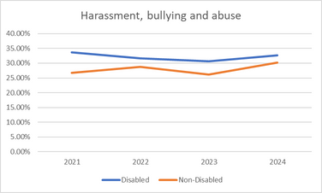
Staff with disabilities experiencing harassment, bullying or abuse from Managers (WDES 4b)
In the 2024 staff survey, the data shows that 11.04% of disabled staff reported incidents of harassment, bullying, and abuse from managers. This represents a notable decline from the previous year’s peak of 13.30%. While this reduction is encouraging and below the national average of 11.4%, the rate remains significantly higher than that for non-disabled staff, who reported incidents at 6.96%.
This disparity highlights an ongoing challenge in fostering an inclusive and psychologically safe workplace for disabled colleagues. The data suggests that while some progress may have been made, the lived experiences of disabled staff continue to reflect disproportionate exposure to negative experiences.
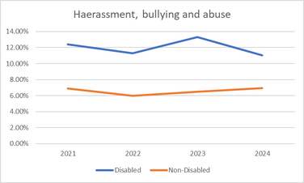

Staff experiencing harassment, bullying or abuse from other Colleagues (WDES 4c)
Disabled staff consistently report higher rates of harassment, bullying, or abuse from colleagues compared to their non-disabled peers. In the 2024 staff survey, 18.80% of disabled staff reported such incidents, compared to 12.20% of non-disabled staff, a gap of 6.6 percentage points, and 17.9% national average for disabled staff.
The rate for disabled staff peaked in 2023 at 19.50%, suggesting a worsening trend before a slight improvement in 2024. A similar improvement was seen for non-disabled staff.
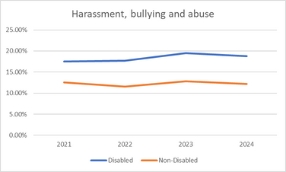
Percentage of staff saying that, the last time they experienced bullying or harassment at work, they or a colleague reported it (WDES 4d)
In 2024, 66.20% of disabled staff who experienced bullying or harassment reported it (either themselves or via a colleague). This is slightly lower than the reporting rate for non-disabled staff of 67.5%, but does reflect a 5.5 percentage point increase for disabled staff compared to 2023. This is a greater increase than was seen for non-disabled staff, suggesting a positive shift in confidence or accessibility of reporting mechanisms amongst staff with disabilities.
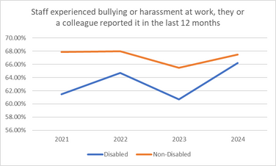
Disability equal opportunities for promotion (WDES 5)
In 2024, only 53.20% of disabled staff believed the Trust provides equal opportunities for career progression or promotion. This compares to 58.00% of non-disabled staff, revealing a 4.8 percentage point gap in perception.
The belief among disabled staff has declined steadily since 2022, dropping by 6.3 percentage points over two years. Non-disabled staff perceptions have also declined, though less sharply, falling by 2.3 percentage points since 2022.
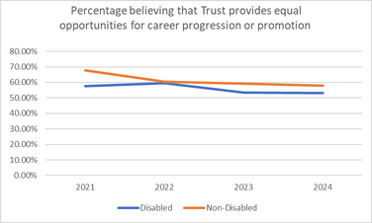
Pressure to work when unwell by disability (WDES 6)
In 2024, 19.20% of disabled staff reported feeling pressured by their manager to attend work despite not feeling well enough to perform their duties. This compares to 10.70% of non-disabled staff, revealing an 8.5 percentage point disparity.
Disabled staff have consistently reported higher levels of pressure over the last four years, with rates nearly double those of non-disabled staff in 2024.
While pressure on non-disabled staff has steadily declined since 2021, the rate among disabled staff has remained relatively static, showing only a modest improvement from the 2021 peak of 23.80%.
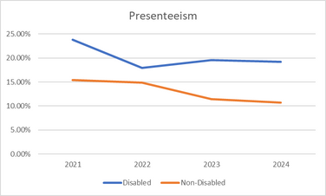
Compared to non-disabled staff saying that they are satisfied with the extent to which their organisation values their work (WDES 7)
In 2024, only 36.60% of disabled staff at KMMH reported feeling satisfied with the extent to which the organisation values their work. This marks a 4.6 percentage point decline from 2023 and places KMMH below the national average for disabled staff satisfaction, which stands at 44.3%.
In contrast, 52.80% of non-disabled staff reported feeling valued—an increase from 2023 and now 16.2 percentage points higher than their disabled colleagues.
The satisfaction gap between disabled and non-disabled staff has widened significantly, from 10.3 percentage points in 2023 to 16.2 percentage points in 2024.

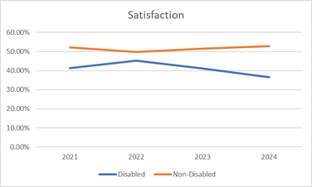
Adequate adjustments for disabled people (WDES 8)
In 2024, 78.20% of disabled staff reported that KMMH had made adequate adjustments to support them in carrying out their work. This figure reflects a slight decline from the 2023 level of 78.30%, and remains below the 2021 peak of 79.20%.
The staff engagement score for Disabled staff, compared to non-disabled staff and the overall engagement score for the organisation (out of 10) (WDES 9)
In 2024, the engagement score for disabled staff dropped to 6.3 out of 10, down from 6.8 in 2023—a 0.5-point decline, and the lowest score in four years.
Non-disabled staff reported a score of 6.9, also down from 7.2 in 2023, but the decline was less steep.
The overall organisational engagement score in 2024 was 6.7, placing disabled staff 0.4 points below the organisational average and 0.6 points below their non-disabled peers.
Board membership disability (WDES 10)
100% of the Board declare themselves to be non-disabled.
Next steps for disability equality 2024-26
Representation & Data
- Encourage ESR declarations, reduce “unknown” declarations and align ESR data with staff survey data
- Improve senior-level disability data
Capability & Support
- Strengthen early resolution and support
Harassment, Bullying & Abuse, Discrimination
- Increase confidence in reporting incidents
- Reduce colleague harassment below national average
Career Progression & Development (Talent)
- Launch mentoring and development into Bands 7–8
- Build leadership pipeline for visible disability representation at Board
Health, Wellbeing & Working Culture
- Train managers to reduce presenteeism pressure
- Increase satisfaction with adjustments to 85%+ and sustain >90%
Staff Engagement & Feeling Valued
- Raise satisfaction levels to approach parity with non-disabled staff

Gender/sex
In 2023/2024, both women and men saw increases in employment, with women’s share rising by 0.24% compared to the previous year (74.92% in 2022/2023). Men also experienced growth of 0.23%, but because the total workforce expanded, their overall proportion decreased slightly from 25.07% in 2022/2023
In the 2024 staff survey only 57.5% of female employees felt there was equal opportunities to career progression compared to 60.3% male counterparts.
Data for Trans or non-binary individuals is currently unavailable.

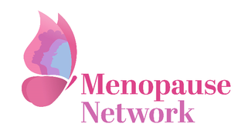
KMMH’s Menopause Network has brought women and non-binary people together to normalise menopause and providing a safe space where symptom and, sharing experiences can be talked about without judgement.
Total Members: 217
Key Achievements and Activities:
- Launching a menopause Network in 2023 aimed normalising menopause within the Trust, achieving the workplace menopause friendly accreditation and launching wellbeing sessions specifically for men support. The menopause network is the fastest growing network.
- Successfully organising and hosting an engaging event in celebration of International Women's Day and world menopause day.
- Refreshing KMMHs comprehensive policy to provide support for colleagues undergoing transition in the workplace.

Key findings: Gender (sex)
Workforce gender representation 2024-2025
Out of 3953 staff, 75% (2952) were recorded as female and 25% (1001) as male on their Electronic Staff Records (ESR) as of 21/08/2025.
At present the national ESR system cannot record staff members who do not identify with a specific binary sex or who prefer to self-describe.
Your health, wellbeing and safety at work by sex/gender
The staff survey data presented includes data for male, female, non-binary, prefer to self-describe and prefer not to say.
Harassment, bullying or abuse from patients, families or the public
The data shows clear variation across sex and gender categories in experiences of harassment, bullying, or abuse:
Female staff: 28.0% reported experiencing harassment, bullying or abuse from patients, families or the public. This is the lowest rate among those who disclosed their gender, though still represents over a quarter of female staff.
Male staff: 37.3% reported such experiences, making this the highest proportion across the reported categories. This indicates that male staff are significantly more likely to report experiencing harassment, bullying, or abuse compared to female staff.
Non-Binary and Prefer to self-describe: Data recorded was fewer than 10 responses, so results are not reported to protect anonymity. However, their inclusion highlights the importance of ensuring smaller gender groups are represented and supported in future monitoring.
Prefer not to say: 32.0% reported harassment, bullying, or abuse. This sits between the female and male proportions, suggesting that staff who do not disclose their gender also face a considerable level of negative experiences
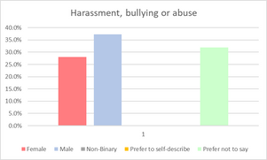
Harassment, bullying or abuse from managers
Female staff: 7.8% reported harassment, bullying or abuse from managers.
Male staff: 7.1% reported similar experiences, showing little difference compared to female staff.
Non-Binary / Prefer to self-describe: Data recorded is fewer than 10 responses, so not disclosed to protect anonymity.
Prefer not to say: 20.0% reported negative experiences – almost three times higher than both female and male staff.
Experiences of harassment, bullying or abuse from managers are relatively low across women and men, with little gender difference.

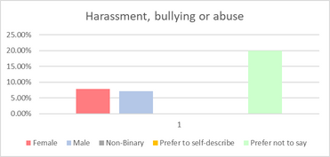

Harassment, bullying or abuse from other colleagues
Female staff: 13.1% reported harassment, bullying or abuse from colleagues.
Male staff: 14.6% reported similar experiences, slightly higher than female staff.
Non-Binary / Prefer to self-describe: Fewer than 10 responses recorded, not disclosed.
Prefer not to say: 30.5% reported harassment, bullying or abuse from colleagues, more than double the rates of female and male staff.
Male staff again report slightly higher levels (14.6%) than female staff (13.1%), but the difference is small.
The “prefer not to say” group stands out, with nearly a third reporting harassment from colleagues. This suggests that staff who feel unable or unwilling to disclose their gender identity are particularly vulnerable to negative treatment.
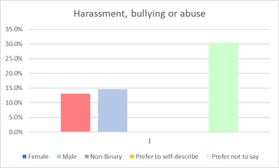
Gender equal opportunities for promotion
Female staff: 57.5% reported feeling positive about career progression.
Male staff: 60.3% reported the same, showing a slightly higher level of positivity than female staff.
Non-Binary / Prefer to self-describe: Data not reported (fewer than 10 responses).
Prefer not to say: 25.0% reported positive perceptions of career progression, significantly lower than both male and female staff.
Perceptions of career progression are broadly positive among women and men, with men reporting slightly higher positivity (60.3%) than women (57.5%).
The “prefer not to say” group stands out with much lower positivity (25.0%), which may suggest that staff who feel less comfortable disclosing their gender identity also feel less optimistic about their career development opportunities.
The lack of sufficient data for non-binary and self-described staff limits insight into their experiences, creating an evidence gap that should be addressed in future reporting.
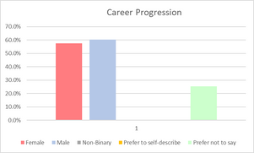

Gender Pay Gap
The 2023-2024 workforce is predominantly female, with women making up 75.2% of staff (2,899 employees) compared with 24.8% men (958 employees). Female representation has increased across all Agenda for Change pay bands, while male representation has risen in most bands except 8b and 9.
 | 2022/2023 |  |  |  | 2023/2024
Band | Female | Female % | Male | Male % | Female | Female % | Male | Male %
2 | 406 | 10.96 | 166 | 4.48 | 381 | 13.14 | 167 | 5.76
3 | 542 | 14.62 | 139 | 3.75 | 560 | 19.32 | 155 | 5.35
4 | 289 | 7.8 | 57 | 1.54 | 332 | 11.45 | 63 | 2.17
5 | 290 | 7.83 | 90 | 2.43 | 296 | 10.21 | 89 | 3.07
6 | 556 | 15.00 | 146 | 3.94 | 594 | 20.49 | 170 | 5.86
7 | 344 | 9.28 | 97 | 2.62 | 341 | 11.76 | 101 | 3.48
8a | 124 | 3.35 | 44 | 1.19 | 150 | 5.17 | 49 | 1.96
8b | 65 | 1.75 | 32 | 0.86 | 57 | 1.97 | 21 | 0.72
8c | 33 | 0.89 | 12 | 0.32 | 35 | 1.21 | 23 | 0.79
8d | 19 | 0.51 | 13 | 0.35 | 17 | 0.59 | 11 | 0.38
9 | 7 | 0.19 | 8 | 0.22 | 8 | 0.28 | 4 | 0.14
Other | 121 | 3.26 | 106 | 2.86 | 128 | 4.42 | 105 | 3.62

Mean analysis
For the reporting year 2023/24, KMMH’s mean gender pay gap stands at 13.5%, down from 15.4% in 2022/23 and continuing a downward (improvement) trend since 2021/22 (16.4%).
KMMH’s gender pay gap is slightly above the national average of 13.1%, but represents measurable progress towards pay equity. The reduction has been driven by a stronger increase in the median hourly rate for women, resulting in a 6.28% reduction in the median pay gap, now at 3.7% compared with 10.0% in 2022/23.
Mean hourly rate | Male (AfC) | Female (AfC) | % Difference
2023/2024 | £22.37 | £19.35 | 13.50%
2022/2023 | £21.60 | £18.27 | 15.40%
2021/2022 | £20.96 | £17.52 | 16.40%
Median analysis
The pay gap has reduced year on year, falling from 12.7% in 2021/2022 to 10.0% in 2022/2023, and again to 3.72% in 2023/2024.
The most recent change (2022/2023 to 2023/2024) shows a 6.28 percentage point reduction in the gap.
This improvement is largely driven by the fact that women’s median hourly pay increased by £1.36 between 2022/2023 and 2023/2024, compared with a smaller increase of £0.22 for men.
Median hourly rate | Male (AfC) | Female (AfC) | % Difference
2023/2024 | £18.22 | £17.54 | 3.72%
2022/2023 | £18.00 | £16.18 | 10.00%
2021/2022 | £17.47 | £15.24 | 12.70%
Men and women percentage per quartile
Women continue to make up the majority across all quartiles, which is consistent with the overall gender profile of the organisation.
The concentration of women in the lowest quartile (81%) remains notable, indicating continued overrepresentation in lower-paid roles.
At the same time, women also represent the majority in the highest quartile (68%), though their share is lower than in the lower quartiles. This suggests women are not underrepresented at senior levels, but the distribution indicates men are relatively more likely to hold higher-paid roles than lower-paid ones.
The small but positive increase in women’s share in both the lowest and highest quartiles indicates some year-on-year improvement in representation at both ends of the pay scale
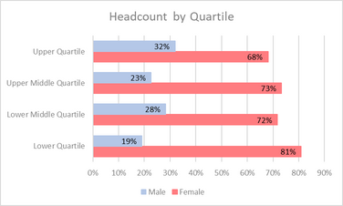
Bonus Payments/Clinical Excellence Awards
Bonus payments (National and Local Clinical Excellence Awards), present a more challenging picture. While the proportion of women receiving bonuses has not changed and the number of men receiving bonuses has decreased, the bonus pay gap has widened significantly.
The mean bonus gap rose to 19.6% (up from 14.4% in 2022/23), and the median bonus gap increased sharply to 44.0% (from 30.0%). These highlights ongoing inequality in performance-related rewards despite overall progress in base pay.
Mean bonus payment | Male | Female | % Difference
2023/2024 | £10919.43 | £8775.18 | 19.64%
2022/2023 | £10121.08 | £8668.62 | 14.35%
2021/2022 | £9088.47 | £8842.22 | 2.71%
Overall, KMMH has made positive strides in reducing its gender pay gap, driven by rising pay rates for women and improved representation across pay bands. However, challenges remain, particularly in the distribution of bonus payments and the concentration of women in lower-paid roles. Continued action is required to ensure fair progression, transparent reward structures, and sustainable reductions in pay inequality.
Next steps for gender equality 2025-27
Pay Gap Monitoring & Transparency
- Continue tracking mean/median pay gap annually
- Monitor bonus distribution by gender annually and address disparities
- Review Clinical Excellence Award criteria and allocation for transparency and fairness
- Report progress to Board annually with clear targets for narrowing both base and bonus pay
Harassment, Bullying & Abuse, Discrimination
- Increase confidence in reporting incidents
- Reduce incidents of harassment, bullying or abuse towards men by patients
Career Pathways & Development (Talent)
- Develop career pathways to support women moving from lower bands into higher-paid roles
- Expand mentoring, leadership, and development opportunities for women into senior roles
Recruitment & Representation
- Promote balanced shortlisting at senior levels
- Ensure gender-diverse recruitment panels

Religion and belief
Religion and belief form an important part of staff identity and workplace inclusion. The data used in this report is taken from KMMH’s Electronic Staff Records. The data shows that while Christianity remains the largest group within the workforce, there is a wide diversity of religious and non-religious beliefs represented.

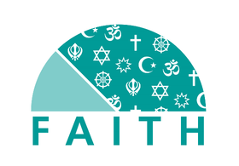
KMMH’s Faith Network has brought disabled staff together, committed to valuing individuality, supporting inclusion and promoting diversity. Key achievements include:
Total Members: 63
Key Achievements and Activities:
The Faith Network doubled in size over the last 12 months, with new members joining each month. Key achievements included:
- Theming each network meeting and hosting guest speakers creating awareness and education.
- Promoting and leading the annual peace walk in Medway visiting different religious establishments.

Key findings: Religion and belief
Workforce religion and belief representation
The workforce is diverse in terms of religion and belief, with Christianity remaining the largest group but making up less than half of staff. A significant proportion of staff identify as atheist, and smaller but meaningful representation exists across a range of world religions. However, a quarter of staff did not provide information on religion and belief, pointing to an opportunity to strengthen trust and inclusion in disclosure practices. Ensuring that both religious and non-religious beliefs are respected and represented will remain key to supporting an inclusive workplace culture
Just under three-quarters of staff (74.47%) have provided information about their religion or belief. This gives a strong basis for understanding the religious and belief diversity within the workforce.
However, over a quarter of staff (25.53%) did not provide this information, either by choosing not to disclose or by leaving the field blank. This is a significant proportion and means that the current data may not fully reflect the true diversity of religion and belief across the workforce.

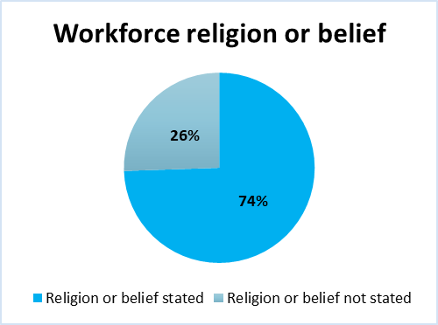

Christianity remains the majority religion, but with less than half of the workforce identifying as Christian, the staff body is religiously diverse, with a substantial proportion either identifying with other faiths or holding no religion.
Nearly one in six staff (16.80%) identify as atheist, showing that non-religious belief systems are an important part of the workforce demographic.
Faith diversity is present, though representation of specific minority religions (e.g., Hinduism, Islam, Sikhism, Judaism, Jainism) is relatively small.
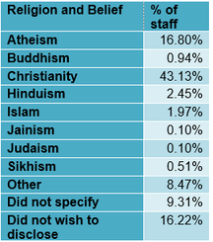

Your health, wellbeing and safety at work by religion and belief.
"We are safe and healthy" measures the responses from the staff survey 2024 concerning personal experiences of harassment, bullying, or abuse from patients, relatives, members of the public, managers, and colleagues.
Harassment, bullying or abuse from patients/service users, relatives or the public
Experiences vary across religious groups.
Hindu staff (33.9%) and Christian staff (33.7%) report the highest levels of harassment, bullying or abuse from patients, relatives of the public, closely followed by Muslim staff (32.6%).
Staff identifying with ‘any other religion’ (38.9%) and those who preferred not to say (36.1%) report even higher levels than most faith groups.
The lowest reported levels are among Buddhist staff (25.9%) and those with no religion (27.1%).
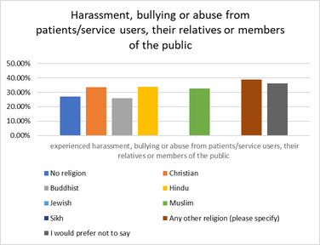

Harassment, bullying or abuse from managers
Hindu staff (1.7%) and Muslim staff (5.0%) report the lowest levels of harassment, bullying or abuse from managers.
The highest rates are seen among staff identifying with ‘any other religion’ (14.7%) and those who preferred not to say (10.5%).
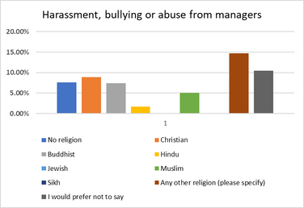

Harassment, bullying or abuse from colleagues
Muslim staff (24.4%), Buddhist staff (25.0%), and those identifying with ‘any other religion’ (25.7%) report significantly higher levels of harassment from colleagues than the majority groups.
Staff with no religion (11.1%) and Christian staff (14.3%) report the lowest levels, below the overall average.
Again, those who preferred not to say (25.9%) report some of the highest levels, comparable to smaller minority faith groups.
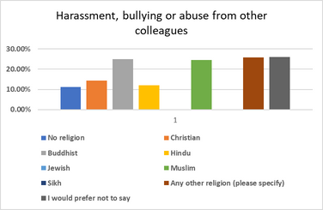
Last experience of harassment, bullying or abuse reported
The highest reporting rates are found among staff with no religion (36.5%) and those who preferred not to say (34.4%). Christian staff (32.0%) and staff identifying with ‘any other religion’ (29.4%) also show higher reporting rates.
Lower rates appear among Hindu staff (22.2%) and especially Muslim staff (13.3%), which may suggest under-reporting or barriers to disclosure.
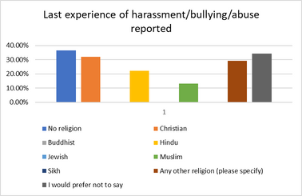

Career Progression
The highest positivity comes from Muslim staff (52.4%) and those who preferred not to say (60.3%).
Lower levels of positivity are reported by Hindu staff (37.5%), Buddhist staff (39.3%), and those with no religion (40.6%).
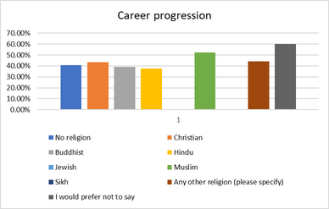

Next steps for religion and belief equality 2025-27
Representation & Data
- Run disclosure campaigns to reduce “prefer not to say”/unknown rates
- Build staff confidence in declaring religion or belief through inclusive messaging
- Use staff survey feedback to monitor fairness, safety, and inclusion by religion/belief group
Networks & Engagement
- Continue to grow the Faith Network with regular meetings and events for diverse religious and non-religious groups
- Partner with staff networks to build dialogue on barriers faced by minority faith and non-religious staff
- Organise and host multifaith events to promote understanding and inclusivity
Harassment, Bullying & Abuse, Discrimination
- Focus interventions on patient/public harassment with clear messaging
- Address higher harassment levels among minority faith and non-disclosing staff with targeted support
- Strengthen safe reporting routes and encourage reporting across all groups

Sexual orientation
Creating an inclusive and supportive workplace for employees of all sexual orientations is a vital aspect of our Equality, Diversity and Inclusion strategy. Representation and visibility matter—not only in attracting and retaining diverse talent, but also in fostering a culture where all colleagues feel safe, respected, and empowered to bring their authentic selves to work.


A KMMH’s LGBTQ+ Network has brought our LGBTQ+ staff together, providing a space for colleagues to share their experiences in the workplace. The network is committed to valuing individuality, supporting inclusion and promoting diversity. Key achievements include:
Total Members: 73
Key Achievements and Activities:
The LGBTQ+ Network over the last 12 months has welcomed new members joining and increased presence at network events. Key achievements included:
- Leading on LGBT History Month and Pride events
- Drop-In Sessions: Monthly staff drop-ins to provide peer support and safe space discussions.
- First guest on the EDI Podcast “All things EDI”
- Celebrated days marked – international lesbian visibility, transphobia week, internal a-sexual awareness event. Agender day, idahobit day (International Day Against Homophobia, Biphobia, Intersexphobia, and Transphobia)

Key findings: Sexual orientation
Workforce sexual orientation representation
The majority of our workforce identifies as heterosexual (just under 76%), with 3.95% of colleagues identifying as LGBTQ+.
It is important to acknowledge that the relatively high percentage of “unspecified” responses (20.06%) suggests that some colleagues may not feel comfortable disclosing their sexual orientation. According to NHS Confederation data LGBTQ + staff represent 1 in 20 of the NHS workforce. Based on the total workforce, around 1 in 25 staff identify as LGBTQ+, when considering only those who disclosed their sexual orientation this increases to around 1 in 20 staff, in line with the NHS Confederation data.
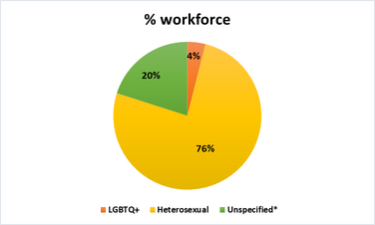
A further breakdown shows the following:
Of the 3953 staff:
- 2.10% Gay/Lesbian
- 1.64% Bisexual,
- 0.20% Other sexual orientation not listed
- 75.99% identify as heterosexual
- 10.65% declined to answer
- 9.23% are unspecified
- 0.18% reported being undecided
Harassment, bullying or abuse from patients/service users, their relatives or members of the public
Bisexual staff reported the highest levels of abuse from patients/service users (39.1%), followed by staff in the “other” category (37.5%). Rates are higher across all minority sexual orientation groups compared with heterosexual staff (30.4%).
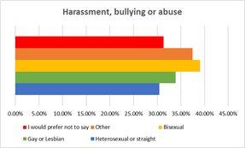

Harassment, bullying or abuse from managers
Gay and lesbian staff are more than twice as likely to experience harassment from managers (18.6%) compared with heterosexual staff (7.5%). This suggests a disproportionate risk for this group.
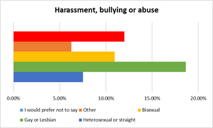

Harassment, bullying or abuse from other colleagues
Rates of harassment, bullying or abuse experienced from other colleagues are broadly similar across disclosed groups (11–14%), but those who prefer not to say report very high rates (25.3%), indicating possible reluctance to disclose identity due to negative workplace culture or fear of repercussions.
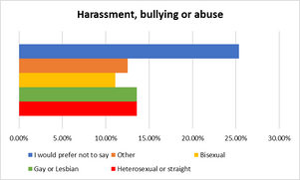

Last experience of harassment/bullying/abuse reported
Where data is available, bisexual staff are less likely to report incidents (28.6%) than heterosexual staff (33.1%). Those preferring not to say reported the highest reporting levels (39.3%), possibly reflecting a desire to act but without disclosing personal identity.
The 2024 staff survey showed that the responses for Gay/Lesbian and too small to report on.
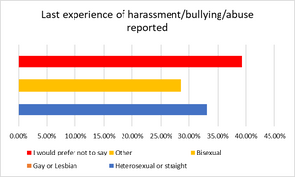

Equality of opportunity for career progression/promotions by sexual orientation
Confidence in the fairness of career progression shows significant variation across sexual orientation groups. Gay and lesbian staff report the lowest confidence, with only 34.5% agreeing that opportunities are fair, compared to 41.8% of heterosexual staff. In contrast, bisexual staff (54.7%) and those identifying as “other” (62.5%) express considerably higher confidence, suggesting that experiences of career progression may differ notably within minority sexual orientation groups.

Next steps for sexual orientation equality 2025-27
Representation & Data
- Encourage more staff to share their sexual orientation by fostering a safe and inclusive environment
- Reduce “unspecified/prefer not to say” responses through disclosure campaigns
- Build trust by reinforcing confidentiality and inclusivity in data collection
Networks & Engagement
- Continue to grow the LGBTQ+ network with regular meetings, support groups, and social events
- Support and resource LGBTQ+ staff networks to amplify voices and influence policy
- Run listening events to understand barriers for LGBTQ+ colleagues
Awareness & Visibility
- Develop LGBTQ+ awareness training for managers and staff
- Highlight positive role models and visible allies across the organisation
Harassment, Bullying & Abuse, Discrimination
- Identify targeted support for LGBTQ+ staff, particularly gay/lesbian staff disproportionately affected by manager harassment

Age
Understanding the age profile of our workforce is an important aspect of Equality, Diversity and Inclusion, as it highlights both generational diversity and the different needs of staff at various career stages. Our workforce spans from colleagues aged 20 years and under through to those aged 71 years and above, reflecting a wide range of experience, perspectives, and career aspirations. This diversity brings valuable strengths, from fresh ideas and digital confidence among younger employees to the depth of knowledge, leadership, and mentorship offered by longer-serving staff. Recognising and supporting the contributions of all age groups is vital to ensuring an inclusive workplace where individuals can thrive at every stage of their working lives

Key findings: Age
The age span within KMMH reflects a multigenerational workforce, offering rich opportunities for cross-generational learning and mentorship.
Workforce age representation
The distribution of KMMH’s workforce across all age groups over the past twelve months is as below:
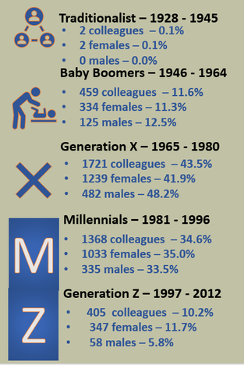

Harassment, bullying or abuse from patients/service users
Younger staff aged 16–20 (63.6%) and 21–30 (65.8%) report the highest levels of experiences of harassment, bullying or abuse from patients/service users, suggesting that early-career staff may feel more vulnerable to negative behaviours from patients or the public.
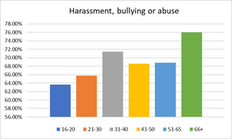

Harassment, bullying or abuse from managers
No 16–20-year olds report experiencing harassment, bullying or abuse from managers, though this may reflect the small sample size. Staff in the 31–40 and 41–50 age ranges report slightly lower rates (~90%), compared with higher reassurance among 66+ (93.8%) and 21–30 (95%).
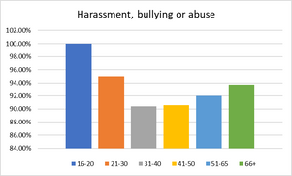

Harassment, bullying or abuse from colleagues
Broadly, experiences of harassment, bullying or abuse from colleagues decrease by age. Only 70% of 16–20 year olds reported no harassment from colleagues, compared to 91.5% of 66+ staff.
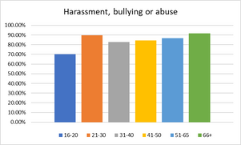

Reporting of harassment/bullying/abuse
Data is unavailable for 16–20 and 66+ groups due to small response rates.
Among those reported, the confidence to report harassment, bullying or abuse when experienced decreases by age.
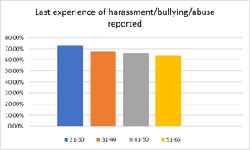

Perceptions of fairness in career progression
Confidence in fairness relating to career progression is highest amongst the younger workforce (16-30 age group). Conversely, staff aged 66+ report the lowest confidence (49%), which may reflect fewer perceived opportunities for late-career progression.
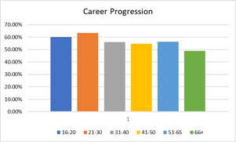

Next steps for age equality 2025-27
Early-Career Staff (16–30)
- Strengthen induction, mentoring, and peer support to reduce vulnerability to harassment
- Provide targeted training on handling patient/public behaviour
Mid-Career Staff (31–50)
- Address lower confidence in fair progression through transparent promotion processes
- Improve reporting confidence with awareness campaigns and manager support
Late-Career Staff (51–66+)
- Promote flexible work and phased retirement options
- Encourage knowledge-sharing and cross-generational mentoring
- Explore pathways for continued career development to address low progression confidence
Cross-Generational Culture
- Build structured mentorship schemes pairing early-career and late-career staff
- Increase awareness of reporting routes across all ages, with focus on mid-career staff where reporting declines
- Monitor harassment/abuse trends by age annually to target interventions

Neurodiversity
KMMH representation of neurodivergent staff is not formally recorded, it is a sub category of disability. Currently 2.22% of staff who have a disability have stated a learning disability/difficulty.
Neurodiversity refers to the natural variation in how people think, learn, process information, and experience the world. It recognises conditions such as autism, ADHD, dyslexia, dyspraxia, Tourette’s syndrome and others as part of human diversity, rather than deficits to be “fixed.” In the workplace, embracing neurodiversity means valuing the unique perspectives and strengths that neurodivergent individuals bring, while also addressing the barriers they may face.

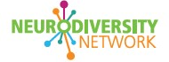
KMMH’s Neurodiversity Network has brought staff who are neurodivergent together, providing a space for staff to share their experiences. The network is committed to valuing individuality, supporting inclusion and promoting diversity.
Key achievements include:
Total Members: 157
Key Achievements and Activities:
- Addressing Neurodiversity: Continued efforts to highlight the impact in the workplace and raise awareness through staff engagement and advocacy.
- Drop-In Sessions: Monthly staff drop-ins to provide peer support and safe space discussions.

Equality Delivery System 2022 (EDS22)
The Equality Delivery System (EDS22) is a system that helps NHS organisations improve the services they provide for their local communities and provide better working environments, free of discrimination, for those who work in the

KMMH has reviewed and submitted the EDS 2022 return to NHS England, key actions are continuous and were included in the submission these are as follows:
- KMMH is continually working towards becoming an anti-discriminatory Trust.
- KMMH is undergoing a change culture programme of which bullying, harassment, violence and aggression is an identified workstream.
- KMMH now has a new dedicated investigations team to ensure consistency in the approach into how investigations are managed.
- EDI inputs on violence and aggression workstreams including introduction of trauma informed care alongside current intervention models.
The 3 services were identified by health inequalities data as priority areas to address disparity in patient/ service user experience, and meeting the Equality Delivery System requirements were Memory Assessment Service, NHS 111 Option 2 Service, and Perinatal Mental Health Services.

Summary of Actions for Equality, Diversity, and Inclusion 2025-2027
This action plan outlines the specific steps and initiatives to advance equality, diversity, and inclusion across the organisation for the period 2025-2027, ensuring alignment with the organisation’s True North the EDI Plan six focus areas and WRES, WDES and GPG.
Theme | Key Actions | Timescale
Representation & Data | - Run declaration campaigns to reduce “unknown”/”prefer not to say” rates (disability, religion, sexual orientation).  - Align ESR data with staff survey data reporting.  - Improve diversity at senior levels (Bands 8–9, Board). | Short: Declaration campaigns  Medium: ESR alignment  Long: Representation targets met/sustained
Recruitment & Progression | - Monitor recruitment outcomes quarterly by protected characteristic.  - Ensure accessible processes and diverse recruitment panels.  - Develop mentoring/leadership pathways (BAME, disability, women, LGBTQ+).  - Address gender pay gap and bonus disparities. | Short: Quarterly monitoring  Medium: Launch mentoring/leadership programmes  Long: Parity in appointment rates; reduce pay gap
Training & Development | - Roll out allyship, anti-racism, LGBTQ+ awareness, and faith inclusion training for managers/staff.  - Ensure equitable access to CPD and training opportunities.  - Expand leadership development programmes. | Short: Awareness training  Medium: Monitor CPD outcomes  Long: Narrow perception gaps in fair progression
Workplace Culture (Harassment, Bullying & Abuse) | Strengthen zero-tolerance campaigns (violence/aggression, bullying/harassment).  - Expand support networks (DAWN, Global Majority, LGBTQ+, Faith).  - Improve safe reporting routes and restorative practices.  - Target interventions for groups with higher harassment rates (disabled, BAME, LGBTQ+, younger staff). | Short: Campaigns & network support  Medium: Strengthen reporting systems  Long: Parity in harassment/abuse experiences
Health, Wellbeing & Support | - Train managers to reduce presenteeism pressures.  - Embed wellbeing-focused policies.  - Increase satisfaction with reasonable adjustments to 85%+, sustaining above 90%. | Short: Manager training  Medium: Raise adjustment satisfaction  Long: Maintain >90% satisfaction
Engagement & Voice | - Run listening events for staff (disabled, LGBTQ+, faith, BAME, age groups).  - Strengthen staff networks with resources, sponsorship, and influence on policy.  - Use pulse surveys and staff survey outcomes to track lived experiences. | Short: Listening events  Medium: Strengthen networks  Long: Monitor impact via surveys
Leadership & Accountability | - Encourage leaders to complete ESR declarations.  - Embed EDI indicators in manager objectives.  - Introduce shadow boards, reverse mentoring, and succession planning.  - Secure visible diversity at Board/senior leadership levels. | Short: ESR declarations & EDI objectives  Medium: Shadow boards & mentoring  Long: Diverse leadership reflective of workforce

