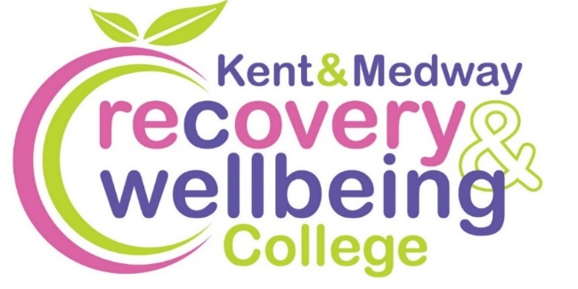
Want to improve your wellbeing?

We provide health-related educational courses for adults free of charge in supportive and accessible learning spaces. Through education, people can make sense of their experiences and learn how to take care of themselves.
Join our free courses in Maidstone
Course | Date | Time | Venue
Introduction to Recovery College | Wed, 14 Jan | 10am to 12 midday | Greensand Health Centre - HEADCORN
How to Say No | Mon, 19 Jan | 1 to 3pm | Maidstone Community Support Centre
Action for Happiness | Tues, 3 Feb | 10am to 12 midday | Fusion Healthy Living Centre
Digital Wellbeing | Wed, 11 Feb | 1 to 3pm | Greensand Health Centre - COXHEATH
Menopause, Mindfulness & Me | Tues, 3, 10, 17 Mar | 10am to 12 midday | Fusion Healthy Living Centre
How to Sleep Well | Wed, 4 Mar | 10am to 12 midday | Greensand Health Centre - HEADCORN
Spring Wellbeing | Wed, 25 Mar | 10am to 12 midday | Greensand Health Centre - COXHEATH
Student Connect | Mon, 30 Mar | 1 to 3pm | Maidstone Community Support Centre

To enrol, scan the QR code, or visit:
https://www.kentmedwaymentalhealth.nhs.uk/about-us/recovery-and-wellbeing-college/
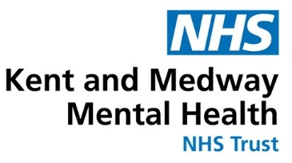
To book call 07407 826920 or email kmmh.maidstonerc@nhs.net

