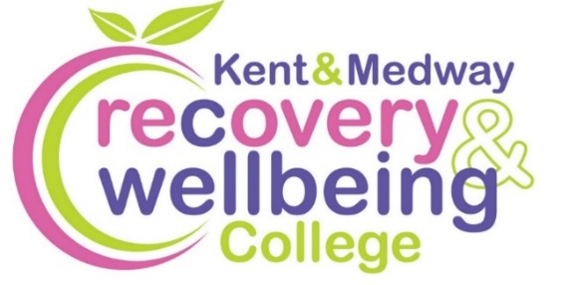
Want to improve your wellbeing?

We provide health-related educational courses for adults free of charge in supportive and accessible learning spaces. Through education, people can make sense of their experiences and learn how to take care of themselves.
Join our free Virtual courses
Course | Date | Time | Venue
Winter Wellbeing | Thurs, 15 Jan | 11am to 12.30pm | MS Teams
Haiku for Wellbeing | Wed, 21 Jan | 11am to 12.30pm | MS Teams
Relax & Breathe | Thurs, 22 Jan | 11am to 12.30pm | MS Teams
Tree of Life | Thurs, 29 Jan & 5, 12 Feb | 11am to 12.30pm | MS Teams
How to Sleep Well | Wed, 4 Feb | 2 to 4pm | MS Teams
Goodbye to Clutter | Wed, 4, 11 Mar & 2 Apr | 12.30 to 2pm | MS Teams
How to Say No | Thurs, 5 & 12 Mar | 11am to 12.30pm | MS Teams
Living Well on a Budget | Wed, 18 Mar | 2 to 3.30pm | MS Teams
Mental Health Toolkit | Wed, 25 Mar | 11am to 12.30pm | MS Teams
Reading for Wellbeing | Wed, 1 Apr | 11am to 12.30pm | MS Teams

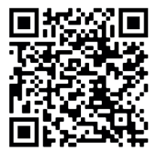
To enrol, scan the QR code, or visit:
https://www.kentmedwaymentalhealth.nhs.uk/about-us/recovery-and-wellbeing-college/

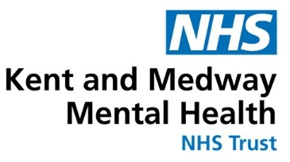
To book call 07787 266421 or email kmmh.virtualrc@nhs.net

