Kent and Medway Mental Health NHS Trust (KMMH) Workforce Disability Equality Standard – 2024/2025
The Workforce Disability Equality Standard (WDES) was launched in March 2019 and required NHS Trusts to measure disabled staff outcomes against a set of ten specific measures (metrics) in comparison to the experiences of non-disabled staff. This data recorded has been analysed by KMMH to develop a local action plan and enable KMMH to demonstrate progress against the indicators of disability equality. As part of the NHS Standard Contract, KMMH is required to provide data for the metrics 1, 2, 3, 9b and 10 using data from ESR and for
metrics 4, 5, 6, 7, 8 and from the Staff Survey.

Overall the data shows a representation of disabled staff across KMMH has increased to 7.8% a slight increase on the 2023/2024 figure of 7.69%. In accordance with NHS England’s WDES data, the national average of disability representation in the NHS is 4.9%.
Below is a breakdown of KMMH’s WDES and action plan:
Workforce disability representation (WDES 1)
The proportion of staff who have recorded a disability is currently 7.8%, which is an increase from 7.69% the previous year. However, the national staff survey indicates 32.7% staff have a disability, which is, again, an increase from 30.6% the previous year. This highlights a gap in KMMH’s ability to identify staff with a disability, which needs to be addressed in order to best meet the needs of this significant part of the workforce.
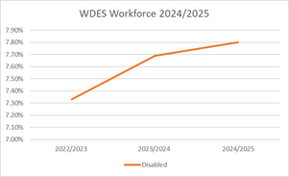

Non-Clinical Staff
Most non-clinical staff identify as non-disabled, with disabled representation varying widely across bands.
- Highest representation: Band 7 (14.6%) and Band 8c (13.6%) show the strongest disabled staff presence.
- Lowest representation: Bands 9, and VSM have 0% declared disabled staff.
- Unknown rates: Very high in senior roles – 44.4% in Band 9 and 73.3% in VSM, limiting data reliability.
- Band 2 Disabled staff are only 3.1%, suggesting potential barriers to recruitment or disclosure at lower levels.
While there is positive mid-band representation, disabled staff are absent from senior leadership and underrepresented at entry levels, with high “unknown” rates at the top masking the true picture.
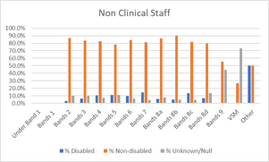
Clinical Staff
The majority of clinical staff across all bands identify as non-disabled (generally 73–83%). Disabled staff representation varies between 2.6% and 12.5%, with no declared disabled staff in Band 9 or VSM. Unknown/null rates remain high in some areas, particularly Band 5 (28.7%), Band 6 (18.1%), and VSM (100%).
- Distribution of disabled staff is fairly equal across pay bands.
- Of the lower banded posts, Band 2 has the lowest representation of disabled staff at 2.62%. Bands 3 and 4 show stronger representation (10.6% and 7.9%) with relatively low unknown rates (~9–11%).
- Disabled staff representation is marginally more consistent amongst the middle pay bands, ranging from 7.9% to 10.7%). Band 5 is notable for its very high unknown rate (28.7%), which may mask true representation.
- Band 7 has one of the highest proportions of disabled staff at 10.7% with other senior bands (8a–8d) being broadly consistent.
- There are no staff who have disclosed disability in Band 9 or VSM roles. Band 9 has a 16.7% unknown rate, and VSM is entirely 100% unknown, making representation at the most senior levels unclear.
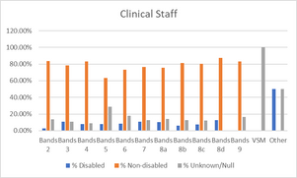
Shortlisting-to-appointment for staff with disabilities (WDES 2)
The data for 2024/2025 shows that disabled applicants made up 9.8% of shortlisted candidates (493 out of 5,009). At the appointment stage, 20 disabled applicants were successful, representing a 4.05% appointment rate. This compares with a 3.66% appointment rate for non-disabled applicants and 6.20% for those who did not state their disability status.
The likelihood ratio for appointment between disabled and non-disabled applicants was 0.92, which is close to parity (1.0). This indicates that disabled applicants were appointed at a rate broadly comparable to, and slightly higher than, their non-disabled counterparts.
Overall, the data suggests that disabled applicants are progressing through the recruitment process fairly and that there is no evidence of disadvantage at either the shortlisting or appointment stages.

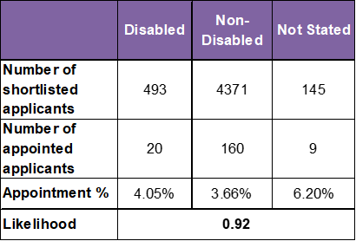

Formal capability likelihood for staff with disabilities (WDES 3)
An analysis of the 2024-2025 data of staff entering a formal capability process shows that 1 disabled staff member and 21 non-disabled staff members were subject to the procedure during the reporting period (for WDES the reporting period was a two-year period - April 2023-March 2025). This represents 0.33% of disabled staff compared with 0.70% of non-disabled staff. No cases across either group were related to ill health.
The likelihood ratio between disabled and non-disabled staff is 0.46, meaning that disabled staff are less than half as likely to enter the formal capability process as their non-disabled colleagues.
Overall, this data indicates that disabled staff are not disproportionately involved in formal capability processes. In fact, they appear less likely to be involved, which is a positive outcome from an EDI perspective. Continued monitoring will help to ensure that this trend remains consistent and that no hidden barriers emerge over time

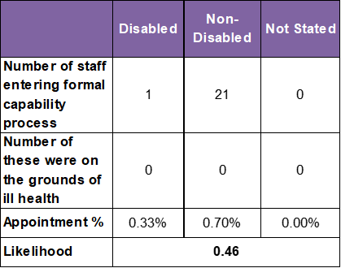
Harassment, bullying or abuse for staff with disabilities (WDES 4a-4d)
Staff experiencing harassment, bullying or abuse from patients, relatives or the public in the last 12 months. ( WDES 4a)
The 2024 staff survey results indicate that disabled staff consistently report higher levels of harassment, bullying or abuse from patients, relatives or the public compared to their non-disabled colleagues.
For disabled staff, there was a positive downward trend between 2021 and 2023 (from 33.7% to 30.6%), but this progress reversed in 2024 with a rise to 32.7%. This is above the national average of 26.6%. A more exaggerated increase however was seen for non-disabled staff.
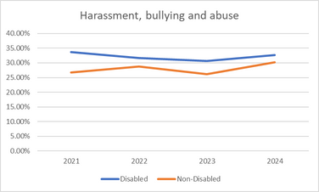

Staff with disabilities experiencing harassment, bullying or abuse from Managers (WDES 4b)
In the 2024 staff survey, the data shows that 11.04% of disabled staff reported incidents of harassment, bullying, and abuse from managers. This represents a notable decline from the previous year’s peak of 13.30%. While this reduction is encouraging and below the national average of 11.4%, the rate remains significantly higher than that for non-disabled staff, who reported incidents at 6.96%.
This disparity highlights an ongoing challenge in fostering an inclusive and psychologically safe workplace for disabled colleagues. The data suggests that while some progress may have been made, the lived experiences of disabled staff continue to reflect disproportionate exposure to negative experiences.
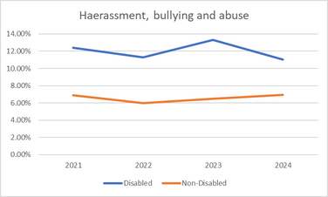

Staff experiencing harassment, bullying or abuse from other Colleagues (WDES 4c)
Disabled staff consistently report higher rates of harassment, bullying, or abuse from colleagues compared to their non-disabled peers. In the 2024 staff survey, 18.80% of disabled staff reported such incidents, compared to 12.20% of non-disabled staff, a gap of 6.6 percentage points, and 17.9% national average for disabled staff.
The rate for disabled staff peaked in 2023 at 19.50%, suggesting a worsening trend before a slight improvement in 2024. A similar improvement was seen for non-disabled staff.
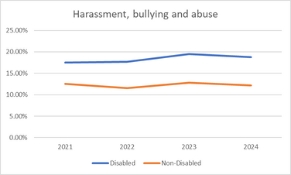

Percentage of staff saying that, the last time they experienced bullying or harassment at work, they or a colleague reported it (WDES 4d)
In 2024, 66.20% of disabled staff who experienced bullying or harassment reported it (either themselves or via a colleague). This is slightly lower than the reporting rate for non-disabled staff of 67.5%, but does reflect a 5.5 percentage point increase for disabled staff compared to 2023. This is a greater increase than was seen for non-disabled staff, suggesting a positive shift in confidence or accessibility of reporting mechanisms amongst staff with disabilities.
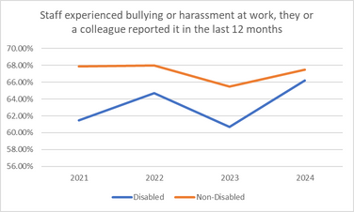
Disability equal opportunities for promotion (WDES 5)
In 2024, only 53.20% of disabled staff believed the Trust provides equal opportunities for career progression or promotion. This compares to 58.00% of non-disabled staff, revealing a 4.8 percentage point gap in perception.
The belief among disabled staff has declined steadily since 2022, dropping by 6.3 percentage points over two years. Non-disabled staff perceptions have also declined, though less sharply, falling by 2.3 percentage points since 2022.
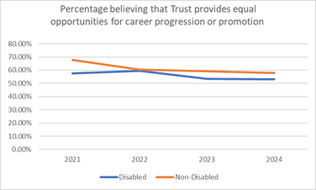
Pressure to work when unwell by disability (WDES 6)
In 2024, 19.20% of disabled staff reported feeling pressured by their manager to attend work despite not feeling well enough to perform their duties. This compares to 10.70% of non-disabled staff, revealing an 8.5 percentage point disparity.
Disabled staff have consistently reported higher levels of pressure over the last four years, with rates nearly double those of non-disabled staff in 2024.
While pressure on non-disabled staff has steadily declined since 2021, the rate among disabled staff has remained relatively static, showing only a modest improvement from the 2021 peak of 23.80%.
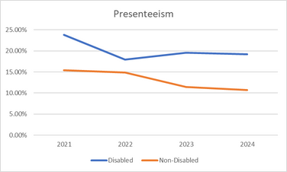
Compared to non-disabled staff saying that they are satisfied with the extent to which their organisation values their work (WDES 7)
In 2024, only 36.60% of disabled staff at KMMH reported feeling satisfied with the extent to which the organisation values their work. This marks a 4.6 percentage point decline from 2023 and places KMMH below the national average for disabled staff satisfaction, which stands at 44.3%.
In contrast, 52.80% of non-disabled staff reported feeling valued—an increase from 2023 and now 16.2 percentage points higher than their disabled colleagues.
The satisfaction gap between disabled and non-disabled staff has widened significantly, from 10.3 percentage points in 2023 to 16.2 percentage points in 2024.

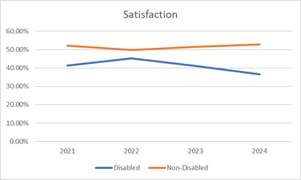
Adequate adjustments for disabled people (WDES 8)
In 2024, 78.20% of disabled staff reported that KMMH had made adequate adjustments to support them in carrying out their work. This figure reflects a slight decline from the 2023 level of 78.30%, and remains below the 2021 peak of 79.20%.
The staff engagement score for Disabled staff, compared to non-disabled staff and the overall engagement score for the organisation (out of 10) (WDES 9)
In 2024, the engagement score for disabled staff dropped to 6.3 out of 10, down from 6.8 in 2023—a 0.5-point decline, and the lowest score in four years.
Non-disabled staff reported a score of 6.9, also down from 7.2 in 2023, but the decline was less steep.
The overall organisational engagement score in 2024 was 6.7, placing disabled staff 0.4 points below the organisational average and 0.6 points below their non-disabled peers.
Board membership disability (WDES 10)
100% of the Board declare themselves to be non-disabled.

Disability Equality Action Plan (2024–26)
Theme | Objectives | Actions | Measures of Success | Timeline
Representation & Data | Increase ESR disability declarations  Reduce “unknown” status  Align ESR & Staff Survey data  Improve senior-leader disability data | Quarterly ESR declaration campaigns  Declaration prompts in onboarding/appraisals  Annual ESR vs Staff Survey comparison  Senior-leader declaration initiative | Reduction in “unknown” declarations  Increased overall declarations  Improved data accuracy  More senior leaders declaring disability status | Start Q1 2024; review quarterly
Capability & Support | Strengthen early resolution support | Manager training on early resolution  Central adjustments hub  Adjustments Passport  Promote OH/EAP/network support | Reduced formal casework  Higher support scores  Increased Passport usage | Training Q2 2024; Hub Q3 2024
Harassment, Bullying, Abuse & Discrimination | Increase confidence reporting incidents  Reduce colleague harassment | Improved reporting mechanisms  Promote safe reporting routes  Behavioural standards workshops  Quarterly incident analysis | Higher reporting confidence  Fewer harassment incidents  Reduced non-reporting | Updates Q2 2024; training ongoing
Career Progression & Development | Improve progression into Bands 7–8  Build leadership pipeline | Targeted mentoring programme  Development pathway for Bands 6–7  Positive-action leadership schemes  Track progression data | More disabled staff in Bands 7–8  Higher leadership participation  Increased senior representation | Mentoring Q3 2024; pipeline Q1 2025
Health, Wellbeing & Working Culture | Reduce presenteeism  Adjustments satisfaction 85% - 90% | Manager training  Adjustment review cycle  Promote flexible working  Wellbeing dashboards | Higher satisfaction  Reduced presenteeism  More flexible working uptake | Training Q2 2024; dashboards Q4 2024
Staff Engagement & Feeling Valued | Raise satisfaction levels  Move toward parity | Senior leader engagement  Quarterly listening events  Disability History Month visibility  You said, we did” updates | Improved survey scores  Higher event attendance  Reduced experience gap | Events from Q2 2024; ongoing

The data analysed from KMMH’s Electronic Records System (ESR) and the 2023 Staff Survey.
NHS England » Workforce Disability Equality Standard: 2023 data analysis report for NHS trusts

