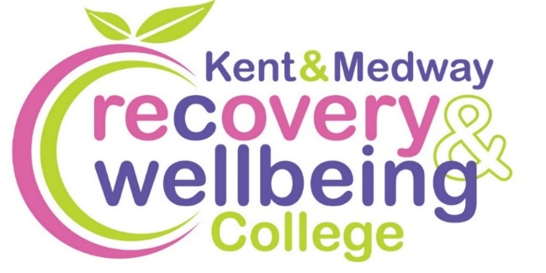
Want to improve your wellbeing?

We provide health-related educational courses for adults free of charge in supportive and accessible learning spaces. Through education, people can make sense of their experiences and learn how to take care of themselves.
Join our free courses in South Kent Coast
Course | Date | Time | Venue
Mental Health Toolkit | Fri, 30 Jan | 1.30pm to 3.30pm | Rainbow Centre, Folkestone
Creativity for Wellbeing – Starlights | Fri, 13 Feb | 1.30pm to 3.30pm | Rainbow Centre, Folkestone
Wilder Wellbeing | Mon, 23 Feb & 2, 9,16, 23, 30 Mar | 10.30am to 12.30pm | Walmer Castle,  Deal
Spring Wellbeing | Thurs, 5 Mar | 11am to 1pm | Hub on the Beach, Greatstone
How to Sleep Well | Fri, 20 Mar | 10.30am to 12.30pm | Age Concern, Sandwich
Reading for Wellbeing | Fri, 27 Mar | 10.30am to 12.30pm | Age Concern, Sandwich

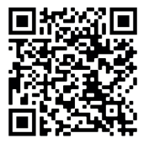
To enrol, scan the QR code, or visit:
https://www.kentmedwaymentalhealth.nhs.uk/about-us/recovery-and-wellbeing-college/

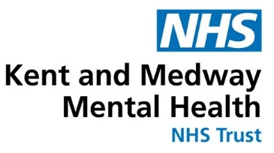
To book call 07721 609018 or email kmmh.southkentcoastrc@nhs.net

