Co- creation strategic plan 2025 - 2028

Our Foundation: a new identity and a new co-creation beginning

Our new identity, centred on Doing Well Together, and guided by our values of being caring, inclusive, curious and confident – sets the tone for how we involve and engage our patients, their families and carers, and communities in shaping our services.

This strategic plan builds on the most extensive engagement the trust has ever undertaken: more than 700 hours of listening and collaboration across all our audiences. Through that work, we have heard clearly that we must do better – to involve more people, more meaningfully, and to reach communities who haven’t accessed our services before.

Working alongside patients, carers, staff and community groups, our new involvement and engagement team has developed this plan and the accompanying co-creation framework. At its core is a commitment to build trust, rebalance power, and improve the experience, equity and quality of our care – in ways we can see, measure and sustain.

We will live our values by:

Caring: approaching every activity with compassion, empathy, and a focus on the wellbeing of our Co-Creation Community and our staff.

Inclusive: ensuring people from every background and circumstance can shape the services they use now and in the future, and trust us.

Curious: being open to learning from diverse voices and willing to explore new ways of working, every day.

Confident: empowering patients, their families, carers and staff to speak up, make changes and lead the future of mental health care.

Our vision

We’re creating a new relationship between people and our care – where patients, families and communities are equal partners in shaping Kent and Medway mental health care that works for them today and in the future.

A co-creation first mindset based on partnerships

We aim to become a truly patient-led organisation where every voice helps design and improve the services they use, based on what matters most to them – their needs, experiences and hopes.

We heard clearly from our communities, patients, their families and carers and staff – people don’t always feel listened to. And when we do listen, we don’t always act, feedback, or empower people to influence change. This plan is about doing things differently.

We are embedding a co-creation first mindset across the trust. One based on relationships, not transactions. One that priorities listening, working side by side and making lasting change together.

Our approach goes beyond one-off engagement. It’s about building long-term, psychologically safe partnerships that result in measurable improvements in care and experience. We’re not just gathering views, we’re co-creating the future of our services.

We want to move beyond relying on a single voice to represent the experience of many. Instead, we are working to reflect the full diversity of our communities – those we serve now and those we need to reach.

This means:

- Actively protecting, valuing and supporting co-creation, making sure all voices feel heard, seen and respected.
- Creating trusted community relationships, working with local groups and organisations to build lasting partnerships based on trust and shared purpose.
- Designing inclusive and accessible routes for involvement, especially for those with the least access to power, influence or previous opportunity to engage.

This new approach is underpinned by our new co-creation framework (see Appendix A), which sets out our shared definitions, expectations and commitments.

Levels of engagement: building deeper partnerships

We recognise that not all engagement is the same, and that meaningful involvement looks different depending on the goal, the people involved and the stage of the journey. We want to shift the centre of gravity of change towards deeper, more sustained co-creation where people are equal partners in shaping change – measured through service improvements and improved co-creator experience.

Below are the five levels of engagement we use, adapted from national best practice. Each level adds value, but our goal is to grow the number of activities happening at the deeper end of this spectrum:

Inform | Engage | Involve | Collaborate | Co-create
Us sharing one-way communication or information to keep people updated | We ask for people’s views on a specific topic or project | People help shape the process and outcomes by contributing insight, experience and ideas | We work together in partnership, sharing decisions and responsibilities in projects | People and staff work side by side throughout – from idea to implementation

From co-creation to impact: how we’ll measure what matters

We’re not interested in measuring activity for its own sake. Our focus is on outcomes – on whether co-creation leads to better experiences, stronger relationships and meaningful improvements in care.

We will measure the difference co-creation makes, not just whether it happened.

Our two overarching outcomes are:

- Improved experience from being involved

We want everyone who takes part in co-creation to feel values, empowered and supported. Their voices should lead to change, and their wellbeing should benefit as a result.

We’ll measure this through:

- % of co-creators reporting improved confidence, connection of sense of purpose (via regular surveys or reflective tools after involvement)
- % of co-creators reporting that their input led to change or made a difference
- % of co-creators reporting improved mental wellbeing or recovery outcomes (need to use adaptive measures developed with patient experience and improvement team pre and post involvement)
- Rich case studies showing how involvement has helped people reframe past experiences, gain purpose or return to work/education

- Improved quality and equity of services because of improvement

We want to show how co-creation improves the care we provide – through better access, experience, safety and outcomes.

We’ll measure this through:

- % of service improvement projects demonstrating measurable change as a result of co-creator input (e.g. shorter waits, fewer complaints, better uptake)
- % increase in satisfaction or experience scores in services that have been co-designed
- % increase in participation from underrepresented groups
- Thematic alignment between co-creator insight and other data sources (e.g. complaints, incidents, PALS feedback)
- Evidence of improved access, equity, and staff-patient relationships in services shaped through co-creation
- % of staff involved in co-design reporting increased understanding of patient, family and carer needs

Bringing it all together in practice

To make sure we capture the full value of co-creation, we’ll take a structured, transparent approach to learning and accountability.

A new Involvement and Engagement Strategic Steering group – led by a member of the new team and made up of cross-functional clinical team members and co-creation community members – to oversee this work, monitor its effectiveness, champion accountability and drive continuous improvement.

The Involvement and Engagement Strategic Steering Group’s role will be to:

- Provide strategic oversight: Guide the direction and priorities of the involvement and engagement team to ensure all activity aligns with the strategic plan
- Monitor implementation: Agree key workstreams/ project groups to ensure that the strategic plan is implemented effectively across the organisation, with clear ownership, milestones and accountability
- Evaluate and monitor impact: Measure impact and adapt activities based on learning and feedback
- Reporting: Take on responsibility for providing regular reports to relevant groups and or/ or committees

To measure our impact, we will develop a simple co-creation impact tool. It will help teams and co-creators track:

  - What changed (experience/service?)
  - How did co-creation influence that?
  - What data/ evidence shows the impact / improvement?

We also plan to develop a deeper understanding of the impact of this work, alongside the work of our patient experience team and through the launch of our new identity – all of which should tell us how we are improving patient experience and outcomes. Our aim is to triangulate different sources of data, feedback and information to build a richer and deeper understanding of what matters most to patients, their loved ones, carers and communities, and enable us to identify trends, highlight areas of success, and uncover opportunities for further improvement. Crucially, our co-creation approach will inform how we respond to patient experience data, in a sustainable way, in the future.

Objectives and key activity

Objective 1: Developing a caring, diverse and empowered co-creation community

We want to grow and sustain a diverse and inclusive network of patients, family members, carers, staff and community partners who help shape and improve our services – and feel supported, valued and empowered as they do.
What success looks like

- Greater diversity: More voices from underrepresented groups are involved, and their insights directly shape improvements.
- Improved experience: Patients, their families and carers feel listened to, respected and involved in decision making – so their confidence and satisfaction with services significantly increases.
- Service insight: Gaps, unmet needs and local challenges are better understood through lived experience and acted on.
- Co-created solutions: Ideas are co-created with the people they affect, making them more practical, inclusive and sustainable.
- A shared sense of purpose: People feel part of something meaningful, untied by the belief that better care is possible, and achievable together.

KEY ACTIONS:
July – December 2025
- Audit the demographics of our current co-creation community and develop a plan to increase diversity and reach.
- Strengthen existing partnerships with Voluntary, Community, and Social Enterprise (VCSE) groups (e.g. MEGAN CIC, Carers First, Speak Up CIC) as well as religious/faith groups to increase engagement with communities that are typically hard to reach.
- Launch a community engagement calendar, aligned to key cultural events and local networks and gatherings.
- Expand our Community Co-creation Champion programme in collaboration with trusted VCSE organisations.
January – June 2026
- Build long-term relationships with community organisations, prioritising trust and continuity in our engagement efforts.
- Develop targeted strategies to grow and sustain diverse representation - ensuring service users feel truly seen, heard and valued.
June 2026 – Onwards
- Evaluate the long-term impact of outreach programmes on community relationships and service change.
- Advocate for sustainable, independent funding for grassroots user-led organisations, enabling them to lead from within.

Objective 2: Ensuring inclusive communication and engagement

We want everyone in Kent and Medway to feel they can take part in shaping our services, and that starts with how we communicate and engage.

Too often language, systems and assumptions get in the way. This is about removing those barriers, creating clear, accessible, and inclusive communications and engagement ways for people to help drive change.

It’s about showing that involvement is for everyone not just those who already know how the system or our trust works.

What success looks like

- Higher participation: More people, from more backgrounds take part because they feel welcome, respected and able to contribute.
- Shared ownership: People see their input reflected in what we do and feel genuinely invested in the outcomes.
- Mutually beneficial relationships: Building on previous research engagement approaches, spending time amongst communities to build genuine connections with people, understand their experience and what they need improves outcomes for both communities and the organisation.
- Trust: Honest, open communication strengthens relationships and makes future collaboration easier.
- More equitable outcomes: Communication that reaches and reflects all communities help reduce inequalities in who engages and who benefits.

key actions

July – September 2025
- Launch a multi-channel engagement strategy using social media platforms and other media to meet people where they feel most comfortable.
- Publish a quarterly newsletter with updates, opportunities and outcomes, written in accessible, plain English .
- Establish a digital presence for our community offering extended opportunities for engagement and reaching a wider audience.
October 2025 – June 2026
- Take co-creation into informal settings (e.g. libraries, food banks, Job Centres) to actively reduce barriers to participation and ensure more equitable access for all.
- Launch flexible event options (evenings, weekends) to reach people beyond traditional hours
- Co-develop a set of inclusive communication principles – using the communications and marketing team’s new brand and identity guidelines which have been co-produced.
- Launch a ‘You Said, We Did’ feedback model to clearly show how co-creator feedback leads to action.
July 2026 – December 2027
- Expand digital accessibility through live chat, virtual forums and SMS updates – building on and ensuring the co-creators needs are embedded in wider trust projects and developments (like the new external website, SMS and patient portal developments).
- Create tailored content for underrepresented groups, ensuring materials reflect the people we serve.
January – December 2028
- Conduct annual reviews of our communication tools and channels, using community feedback to refine and improve.

Objective 3: Creating a curious and psychologically safe co-creation environment

Curiosity is at the heart of great co-creation. We want to build a culture where people feel safe to ask bold questions, share different perspectives, and challenge assumptions without fear of judgement. A space where disagreement can be respectful, ideas can be tested and everyone feels confident that their voice matters.

What success looks like

- Better problem solving: We did deeper into the ‘why’ tackling root causes, not just surface issues and coming up with solutions before we fully understand the challenges and opportunities from all perspectives.
- Positive disruptive: People feel safe to challenge the status quo, helping us improve outdated practices and find better ways to improve.
- Deeper empathy: Curiosity encourages active listening, helping us understand different experiences and design more inclusive solutions.
- Authentic participation: people bring their whole selves – contributing ideas, experience and energy with confidence and purpose.

KEY ACTIONS

July – September 2025
- Develop a series of guidance documents to clearly outline departmental policies and procedures
- Launch a series of “curiosity conversations”—safe, informal spaces for people to explore ideas and challenges together and to be part of the team problem-solving. We will start with a conversation on integrated and collaborative clinical care models.
- Develop “curious questions” workshops to support co-creators and staff to ask open, insightful questions that lead to deeper understanding.
January – June 2026
- Develop a process to outline our pathway to impact to map how we expect our work to make a meaningful difference
- Introduce reflective practice journals for co-creators and staff to record learnings, perspectives, and ideas sparked through engagement activities.
- Embed curiosity prompts into all co-creation sessions (e.g. "what’s missing?", "what haven’t we thought of?", "whose voices are still unheard?").
July 2026 – December 2027
- Co-create “learning labs” in partnership with clinicians, communities, academics, local organisations, and other innovation teams to explore mental health themes identified by the community in creative and meaningful ways.
- Host an annual “curiosity in co-creation” event to share creative ideas, unexpected insights, and community-led provocations from across the system.
January – December 2028
- Evaluate how curiosity has influenced service design and co-creation practices through community feedback and case studies, and service design reviews.
- Launch a curiosity toolkit for teams and co-creators to support safe exploration, critical thinking, and imaginative engagement across projects.

Objective 4: Building confidence and capacity in co-creation

To make co-creation real, we need people who feel confident doing it. Not just in our trust but across the wider health and care system in Kent and Medway.

This objective is about developing skills, confidence and leadership of everyone involved. It’s also about recognising that being involved in shaping care can be part of recovery, growth and purpose.

We want people to feel capable and empowered with the tools, training and trust to lead change in partnership. As we grow our internal capability, we’re also increasingly being asked to support others – from the ICB to local universities – to embed inclusive, co-produced approaches in their own work. That demand reflects the strength of what we’re building and it’s something we embrace with pride. This is not just a movement within our trust, but a system wide shift in how people are heard, valued and involved.

What success looks like

For co-creators
- Greater agency: people feel their ideas matter and that they’re supported to influence real decisions.
- Personal growth: Involvement builds confidence, skills and purpose, supporting recovery and self-belief.
- Recognised expertise: people’s lived experience is valued as professional knowledge – and they’re seen as equal partners.
- Practical skills: co-creators gain transferable skills and tools that open up new opportunities.

For the organisation - and the system
- Better insight: staff and services learn from co-creators’ perspectives, driving more inclusive and effective change.
- Co-creation Accreditation - We are keen to learn from our colleagues at East London NHS Foundation Trust and will seek to develop an internal accreditation for services as a way to demonstrate their commitment to embedding co-creation within their practice.
- Stronger solutions: services shaped by people who use them are more likely to work – and to last.
- A more inclusive system: as co-creators grow in confidence, they help shift culture and expectations across the trust.
- System influence: as we embed co-creation into our culture and county wide due to our unique geographical spread, we’re increasingly asked to lead this work beyond mental health (we have already been asked to support Canterbury Christ Church University and our system partners to build more inclusive and trusted approaches and relationships on their behalf).
- A more equitable future: our co-creators help shift how decisions are made – not just in mental health and our trust, but across Kent and Medway.

Key Actions:

July – December 2025
- Launch a modular co-creation training offer in partnership with Canterbury Christ Church University covering trauma-informed engagement, inclusive communication, and partnership working for everyone.
- Develop tailored personal development plans for all co-creators.
- Create a trust co-creation offer for system partners (e.g. system partners universities, councils) including training, mentoring and practical toolkits to support embedding co-creation across the system.
- Gain a further understanding of the accreditation developed by East London NHS Foundation Trust and begin to develop our own accreditation system.
- Work in collaboration with communications and patient experience colleagues to triangulate multiple sources of data, feedback and information to enable us to identify trends, highlight areas of success, and uncover opportunities for further improvement
January – June 2026
- Expand training to include digital access, safeguarding and facilitation skills, helping co-creators shape and lead engagement.
- Share a Co-Creation Resource Pack, including jargon busters, best-practice guides, and role expectations to support confidence and consistency.
- Identity and train ‘system co-creation ambassadors’ to represent our trust in system-level forums, steering groups and innovation projects.
- Formalise partnerships with system organisations who request co-creation support.
- Together with patient experience colleagues, we will pilot a new Co-creation accreditation with a small number of services. Then refine the process before wider role out.
July 2026 – December 2027
- Pilot cross-system co-design projects on joint priority projects (e.g. greater alignment with community and mental health services).
- Establish informal peer support and mentoring sessions to offer emotional and developmental support.
- Adapt training based on feedback from co-creators, ensuring it stays relevant, reflective and empowering.
- Host an annual Kent & Medway co-creation learning event led by us, spotlighting lived experience leaders, innovation and co-designed outcomes across sectors.
- Campaign and role out of new Co-creation accreditation for services to serve as a clear bench mark, encouraging teams to actively involve co-creators in meaningful collaboration throughout service design and delivery. By establishing and recognised organisational standard, the accreditation would not only encourage consistent and authentic co-creation but lend itself to wider celebrations, creating a culture where everyone, working in equal partnership, are central to improving outcomes.
January – December 2028
- Evaluate the long-term impact of training and support outcomes.
- Create a structured, trust-wide support network that champions co-creation and builds leadership pathways across services.
- Develop and publish a system wide co-creation impact report.

Barriers and mitigations in taking this approach

Subject | Barrier | Mitigation
Cultural resistance | Staff or service users/carers resist changing from traditional engagement approaches | Provide training and awareness on co-creation its benefits, highlighting success stories.  Develop a cohort of staff champions
Engagement fatigue | Service users, carers and community members feel tired of repeatedly sharing experiences without visible change, leading to disengagement and mistrust. | Communicate clearly how feedback has led to changes, provide regular updates on progress, celebrate small successes and demonstrate impact.  Expand Community Co-creation Champion programme.
Lack of clarity around the term ‘co-creation’ | Unclear definition and purpose of co-creation leads to confusion or inconsistency. | Develop clear definitions and a shared language. Communicate this widely and incorporate in training.
Representation issues | Limited diversity in co-creation community undermines inclusivity. | Proactively recruit diverse voices, ensure accessibility, work with community champions and partner organisations who are trusted within those communities. Match diversity of pool with diversity of our communities.
Technology barriers | Digital exclusion limits participation in virtual co-creation. | Provide digital support, training and offline options to co-creators adapted to the needs of the project. Combine with in-person community-based activity.
Confidentiality concerns | Co-creators have fears around sharing information or experiences in open forums. | Develop trusting, authentic relationships. Set clear ground rules, offer anonymised options, provide safe spaces for participation.
Evaluation challenges | Difficulty measuring the impact or value of co-creation | Develop clear metrics aligned to strategic goals, triangulation of patient experience data to measure impact.

Reporting on our impact internally and beyond

We are committed to being open and accountable for the impact of this strategy. To strengthen governance and assurance, the new Steering Group will report directly to the Trust’s Quality Committee. We will also share what we’re learning more widely – through six monthly updates, annual impact summaries and opportunities for co-creators and community voices to present their voices and work directly to Board, system partners and peers. We will offer leadership and support across Kent and Medway – working with partners to embed this in the wider system because doing well together means learning together. And sharing power means sharing responsibility – for what we do, how we do it, and the different it makes.

APPENDIX A: Involvement and Engagement Co-creation Framework
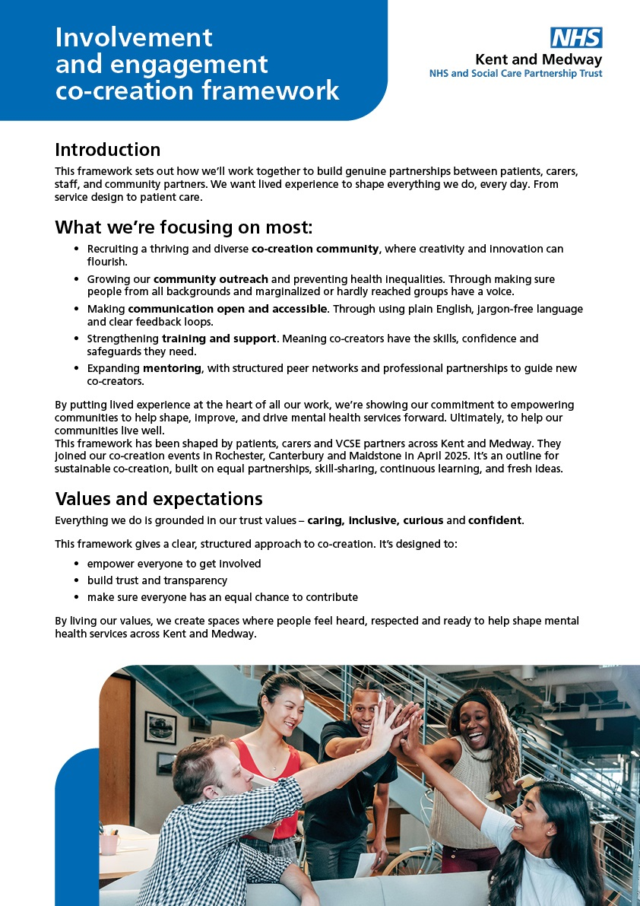
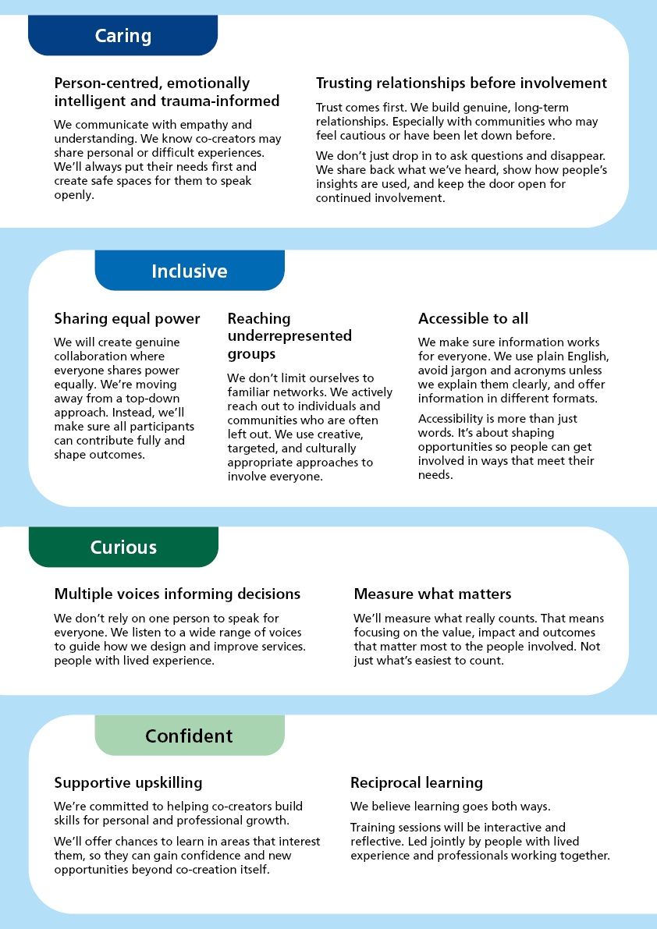

APPENDIX B: Development of the Co-creation Framework and Strategic Plan

The development of the framework and strategy followed an inclusive methodology, rooted in co-creation principles. It included the following:

Listening Phase – As part of our commitment to meaningful involvement and engagement, we held three listening events with patients, carers, families, VCSE colleagues and local communities during the month of May. We focused on areas of engagement stakeholders felt we had done well, what we had not done so well and how they would like our approach to change in the future. We held one event in Medway, one in Canterbury, and one in Maidstone. These sessions provided a valuable opportunity to gather direct insights, experiences, and ideas from those who use and support our services on how they would like the organisation to engage with them moving forward. The feedback and intelligence collected during these events played a crucial role in shaping the key principles of our co-creation framework and strategic plan, ensuring it is grounded in the real needs and priorities of the people that we serve.
Staff are also a key stakeholder in ensuring that our approach to co-creation is embedded across the organisation. Many staff within our organisation have vast experience of engaging with patients and carers to improve our services, and it would have been prudent to not ask of staff what they believe is important when engaging with patient's carers and families in the communities. A series of online listening sessions were held with staff over the course of 1 week, and were attended by individuals from a variety of professional backgrounds.

Drafting and ‘Feedback Week’ - The Involvement and Engagement team worked collaboratively to develop a first draft of the framework and strategic plan by carefully reviewing and drawing together the ideas, experiences and priorities shared by the participants at the co-creation events. To ensure the first draft accurately captured the diverse range of perspectives and feedback, we circulated it to all attendees of the events. This step allowed participants to review the content, sense check our interpretation of their input, and assess whether their views had been understood and represented appropriately. To further support this process, we then hosted a series of online feedback sessions, creating space for open dialogue and collaborative reflection. These sessions provided an opportunity for individuals to highlight anything that may have been missed or misinterpreted, offer additional insights, and help refine the document. This inclusive and iterative approach ensured that the final version of the framework and strategic plan was genuinely written in collaboration with our co-creators.

Final Testing and Endorsement - Participants in the co-creation events responded with strong support and enthusiasm for the new framework. Many offered positive and appreciative feedback, noting that the process felt inclusive, transparent and genuinely collaborative. They highlighted that their contributions had been actively listened to, respected and thoughtfully incorporated into the final version of the documents. There was a clear sense among attendees at their lived experiences, perspectives and priorities were not only acknowledged but also meaningfully represented in the direction and content of the strategic plan. This collective endorsement reflects the success of the co-creation approach and demonstrates the importance of continued partnership working in shaping services that truly reflect the needs of our communities.

