Kent and Medway Mental Health NHS Trust (KMMH) Workforce Race Equality Standard 2024/2025
KMMH’s Workforce Race Equality Standard (WRES) was introduced in within the NHS in 2015 to focus on the experiences of KMMH BAME staff in the workplace compared to White staff. The Workforce Race Equality Standard (WRES) provides a framework for NHS Trusts to report, demonstrate and monitor progress against a number of indicators of workforce equality, and to ensure that employees from Black, Asian and Minority Ethnic (BAME) backgrounds receive fair treatment in the workplace and have equal access to career opportunities. NHS Trusts are required to publish their data at yearly intervals to show progress from the previous year. It is therefore mandatory for KMMH to report on WRES and track progress.
The WRES focuses on meeting requirements around ethnicity on 9 Race Equality Indicators. These indicators are a combination of workforce data and results from the National Staff Survey 2024. Indicators 1-4 and 9 are based on data taken from ESR, Recruitment, Employee Relations and Learning and Development. Indicator 9 has been verified by the Trust Secretary. Indicators 5-8 are based on data from KMMH’s 2024 staff survey.
Overall the data shows a representation of KMMH’s BAME staff across KMMH has increased to 30.0% in 2024/2025. In accordance with NHS England’s WRES data, the BAME representation in the NHS across the South East is 26.4% and across England nationally is also 26.4% up from 24.2% in 2022.
Indicator 1 - Percentage of staff in each of the Agenda for Change (AfC) Bands 1-9 or Medical and Dental subgroups and VSM (including executive Board members) compared with the percentage of staff in the overall workforce.
Indicator 2- Relative likelihood of staff being appointed from shortlisting across all posts
Indicator 3 - Relative likelihood of staff entering the formal disciplinary process, as measured by entry into a formal disciplinary investigation
Indicator 4 - Relative likelihood of staff accessing non-mandatory training and CPD
Indicator 5 - Percentage of staff experiencing harassment, bullying or abuse from patients, relatives or the public in the last 12 months.
Indicator 6 - Percentage of staff experiencing harassment, bullying or abuse from staff in the last 12 months.
Indicator 7 - Percentage believing that Trust provides equal opportunities for career progression or promotion.
Indicator 8 - In the last 12 months have you personally experienced discrimination at work from any of the following: Manager/team leaders or other colleagues?
Indicator 9 - Percentage difference between the organisations’ Board voting membership and its overall workforce
It should be noted that the data for indicators 5-8 are not included in the WRES template submission.

Workforce ethnicity representation (WRES 1)
The number of BAME people in the workforce at 31 March 2025 was 1165, or 30% of the workforce overall. The Trust’s BAME workforce has grown by over 6.5% over the past four years.

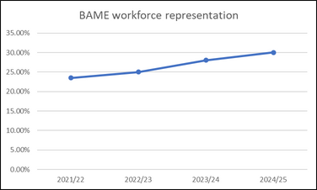

Workforce Race Equality Standard (WRES) Analysis: Clinical and Non-Clinical Staff (2024/2025)
This section provides an analysis of workforce ethnicity data for clinical and non-clinical roles across pay bands for 2024/2025. The data offers insight into representation of White, BAME, and Unknown ethnic groups across all levels, highlighting trends and potential areas for action.
Non-Clinical Staff
Non-clinical roles show higher White representation at all pay bands, with BAME representation significantly lower as bandings increase.
- Representation steadily declines with each higher band.
- From Band 5 upwards, BAME representation ranges from 0.3% to 0.07%, indicating a drop-off in diversity in more senior non-clinical roles.
- At Band 9 and VSM, BAME representation is small.
There is a clear underrepresentation of BAME staff in higher non-clinical pay bands, suggesting barriers to progression or limited opportunities for advancement.
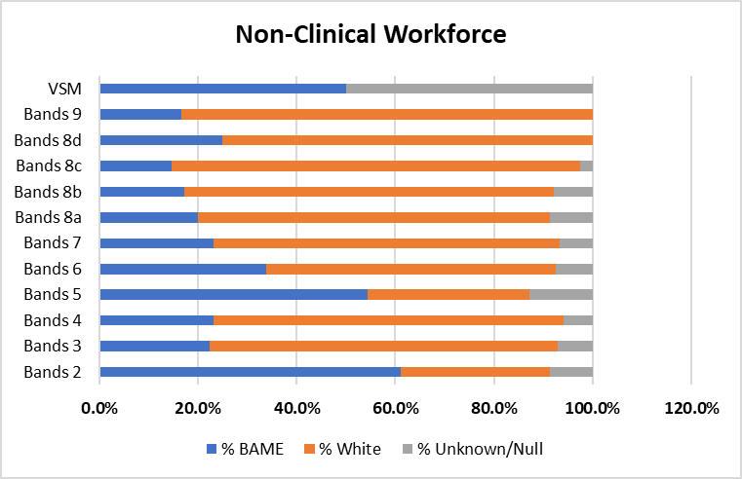

Clinical Staff
BAME representation is consistently higher in clinical roles than in non-clinical ones, especially in the middle bands and medical grades.
- There is a strong BAME presence, peaking at Band 5 (4.7%) and Band 2 (4.1%).
- BAME representation at Band 6 is 6.0%, indicating continued diversity into mid-band levels.
- However, representation drops to 2.2% at Band 7.
- There is a reduction in BAME representation in the higher banding e.g., 0.7% at 8A, falling to 0.05% at 8D, indicating a diversity gap at senior clinical management levels.

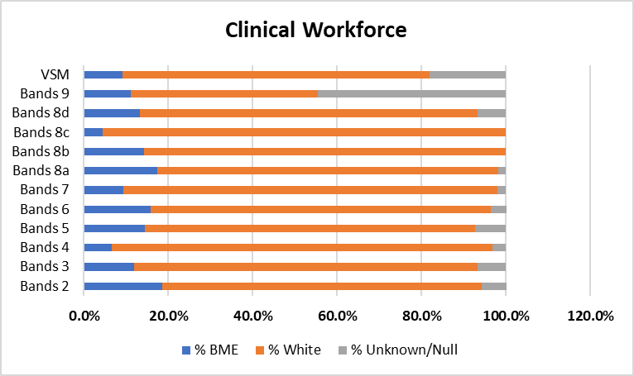

Consultant and Medical Roles:
Staff Group | BAME | White
Consultants | 58.76% | 36.08%
Senior Medical Managers* | 100% | 0%
Non-Consultant Career Grades | 82.61% | 7.25%
Trainee Grades | 66.67% | 31.37%
Other Medical and Dental | 0% | 100%
*Small numbers should be noted (only 2 staff in each category)
BAME staff make up 67.58% of the Medical & Dental workforce, with White staff at 26.48% and 5.94% unknown.
- High BAME representation overall, especially in non-consultant and trainee roles.
- BAME representation declines at consultant level.
- All senior medical managers are BAME
- White staff are more proportionally represented in consultant and trainee positions compared to non-consultant grades.

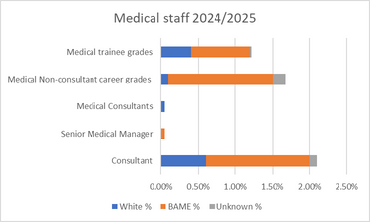

BAME shortlisting-to-appointment likelihood (WRES 2)
In 2024-25, 106 individuals from a BAME background and 86 white individuals were appointed. White applicants were 1.18 times more likely to be appointed from shortlisting compared to those from a BAME background.
However, the data represents a positive improvement of 1.4 percentage points from the previous year, when white individuals were 2.58 times more likely to be appointed.
While KMMH has made strides in improving BAME representation across the workforce, this data reveals there is still a disparity at the final selection stage of recruitment. A relative likelihood ratio above 1.0 indicates that white candidates are considerably more likely to progress from shortlisting to appointment compared to BAME counterparts. This may reflect systemic barriers or unconscious bias during the interview and selection process.
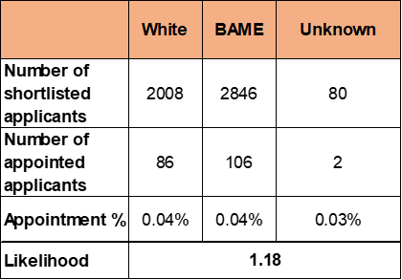

Formal disciplinary likelihood by BAME (WRES 3)
The relative likelihood of BAME staff entering a formal disciplinary process compared to white staff is 2.62. This does signal disproportionality in how disciplinary cases are initiated, while the overall number of disciplinary actions is low, the imbalance, particularly when the benchmark for fairness is a ratio of 1.0.
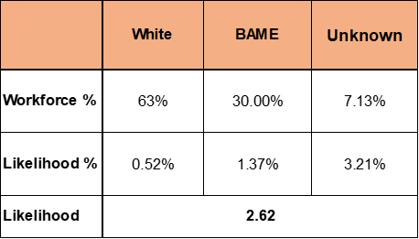

Non-mandatory training (WRES 4)
BAME staff are more likely to access non-mandatory training and CPD than white staff, with a relative likelihood of 0.86 for white staff compared to BAME staff. This suggests positive progress in ensuring equitable access to professional development opportunities across BAME groups.
The data highlights that KMMH is performing well in facilitating access to non-mandatory learning for BAME staff. This trend reflects efforts made to promote inclusive development and could strengthen workforce diversity in future leadership pipelines.
However, while accessing rates are positive, it is vital that this engagement translates into measurable outcomes, such as confidence in progression, promotions and improved survey feedback regarding equal opportunities.
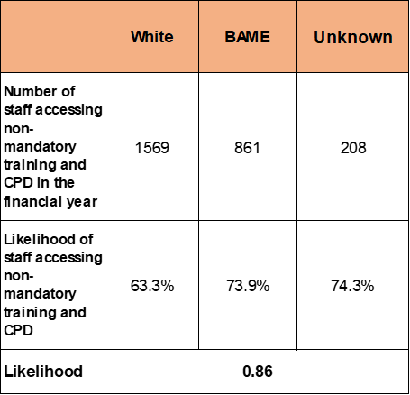

Harassment, bullying or abuse by ethnicity (WRES 5-6)
Staff experiencing harassment, bullying or abuse from patients, relatives or the public in the last 12 months.
The data shows the percentage of White and BAME staff who reported experiencing harassment, bullying, or abuse from patients, relatives, or the public across four consecutive staff surveys (2021 to 2024). There is a sharp increase in reports from BAME staff in 2024, rising to 42.7%, up from 35.2% in 2023, which is a 7.5 percentage point increase. There was also an increase in reports from White staff in 2024, but this was more modest (27.1% from 25.3%).
The gap between White and BAME staff experiences has widened in 2024, indicating persistent and worsening disparities in the experiences of abuse from the public.
The increase in BAME responses (from 400 to 491) strengthens the data’s reliability, though it also highlights that a larger proportion of BAME staff are reporting negative experiences.
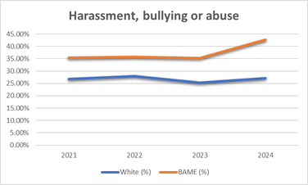

Staff experiencing harassment, bullying or abuse from staff in the last 12 months
In the latest staff survey, 19.4% of BAME staff reported experiencing harassment, bullying, or abuse from other staff within the past 12 months. This is higher than the proportion of White staff, although represents a slight reduction of 0.4 percentage points compared to the previous year and remains below the national average for BAME staff, which stands at 20.9%.
Notably, the overall proportion of staff (both White and BAME) reporting such experiences has not significantly improved over time, suggesting that workplace culture challenges persist.
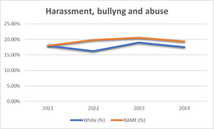

Percentage believing that Trust provides equal opportunities for career progression or promotion
The proportion of BAME staff reporting that the Trust provides equal opportunities for career progression or promotion improved from 47.3% in 2023 to 50.6% in 2024, compared with a moderate deterioration for White staff.
BAME staff consistently report lower agreement that the trust offers equal opportunities than White staff. The gap in perception between White and BAME staff peaked in 2023 (13.4%) and in 2024, the gap reduced significantly to 7.8%, indicating some positive progress toward equity, possibly due to targeted interventions or awareness efforts.
The reduction in the ethnicity gap in 2024 is promising, but continued efforts are needed to sustain and improve this trend.
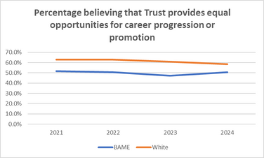

Staff work discrimination by ethnicity (WRES 8)
BAME staff have consistently higher levels of reported discrimination than white colleagues across all years. The data shows this peaked in 2023 at 13.7%, the highest across the four-year period. However, there is an improvement in 2024 (10.2%), indicating positive movement, though still higher than 2021 levels.
BAME staff report approximately twice the rate of discrimination as White staff in most years. However, like for opportunities for career progression, the gap between BAME and White staff was largest in 2023 (6.3 percentage points), and encouragingly, narrowed to 3.3 percentage points in 2024. This suggests that EDI interventions may be starting to take effect, but continued efforts are necessary.

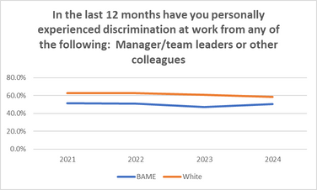

Board membership ethnicity (WRES 9)
White individuals make up 84.6% of voting board members, while constituting 67.2% of the overall workforce. This is a 17.4 percentage point overrepresentation at the voting board level.
BAME individuals account for 15.4% of voting board members, compared to 30% of the workforce. This is a 12.8 percentage point underrepresentation at board level.
While 200 staff (5.2%) have unknown ethnicity, 0% of voting board members are recorded as Unknown. This suggests more complete ethnicity data is recorded at senior levels than across the wider workforce.
Despite one BAME voting board member, BAME staff remain significantly underrepresented at senior leadership level compared to their workforce presence. Whereas, White individuals are overrepresented on the voting board, which may reinforce perceptions of inequality in access to leadership roles.
Lack of representative leadership can impact BAME staff morale, engagement, and confidence in the organisation’s commitment to inclusion. It also limits the presence of diverse voices in strategic decision-making, which can affect organisational culture and service delivery

Race Equality Action Plan (2025–27)
Theme | Objectives | Actions | Measures of Success | Timeline
Talent Development | Develop progression pathways  Explore mentoring & leadership Inclusive recruitment & promotion  Career conversations with BAME staff  Link appraisals to succession planning  Monitor survey fairness outcomes | Define progression pathways  Launch mentoring/leadership programmes  Review recruitment processes  Hold career conversations  Integrate succession planning in appraisals  Monitor fairness survey outcomes | Increased progression rates  Improved fairness metrics  Higher BAME participation in development schemes | Start 2025; review annually
Recruitment Outcomes | Analyse shortlisting - appointment gaps  Implement diverse recruitment panels | Quarterly review of recruitment gaps  Introduce diverse panels across all bands | Reduced recruitment disparities  Increased panel diversity compliance | From Q2 2025; quarterly tracking
Harassment, Bullying, Abuse & Discrimination | Strengthen early resolution  Train managers in restorative practice  Improve violence & aggression initiatives  Enhance safe reporting  Introduce restorative conflict processes | Early resolution training  Restorative practice workshops  Violence & aggression prevention actions  Update reporting systems  Roll out restorative conflict approaches | Higher confidence to report  Reduced incidents  Faster resolution times | Training Q3 2025; ongoing
Leadership Representation | Explore BAME shadow board  Explore reverse mentoring  Build BAME succession pipelines | Scope & design shadow board  Implement reverse mentoring  Develop targeted succession programmes | Increased BAME leadership visibility  Progression into senior roles  Engagement in mentoring initiatives | Shadow board scoping 2025; pipeline 2026

The data analysed from KMMH’s Electronic Records System (ESR) and the 2022 Staff Survey.

