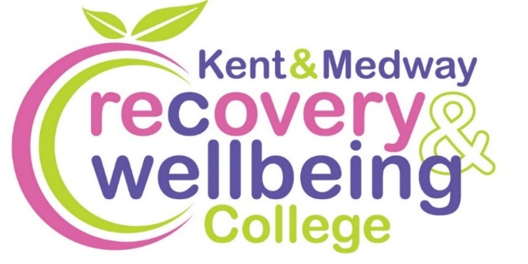
Want to improve your wellbeing?

We provide health-related educational courses for adults free of charge in supportive and accessible learning spaces. Through education, people can make sense of their experiences and learn how to take care of themselves.
Join our free courses in Sevenoaks

Course | Date | Time | Venue
Introduction to Recovery College | Tues, 13 Jan | 12.30 to 2.30pm | Sevenoaks Leisure Centre
Reading for Wellbeing | Thurs, 22 Jan | 12.30 to 2.30pm | Sevenoaks Leisure Centre
Men’s Sheds | Thurs, 29 Jan | 12.30 to 2.30pm | Bat & Ball Luggage Room
Discovering Your Inner Strength and Potential | Thurs, 5, 12 Feb | 12.30 to 2.30pm | Sevenoaks Leisure Centre
Mindful Living | Thurs, 5, 12, 19 Mar | 12.30 to 2.30pm | Sevenoaks Leisure Centre
Living Well on a Budget | Tues, 17 Mar | 12.30 to 2.30pm | Sevenoaks Leisure Centre
Student Connect | Thurs, 2 April | 12.30 to 2.30pm | Bat & Ball Luggage Room

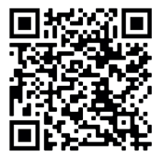
To enrol, scan the QR code, or visit:
https://www.kentmedwaymentalhealth.nhs.uk/about-us/recovery-and-wellbeing-college/

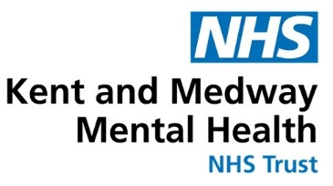
To book call 07711 919610 or email kmmh.sevenoaksrc@nhs.net

