Kent and Medway All Eating Disorder Service- ARFID 3 DAY FOOD DIARY
If you would like to make a referral, please complete this food diary over 3 days and upload to the ARFID referral form for submission. Further information can be found on the web page

- Note down all food eaten, including snacks, all drinks, any nutritional supplements, and tube feeds (if appropriate)
- Describe the type of food and approximate amount eaten with as much detail as possible
- Please record each item separately, e.g., cheese sandwich: 2 slices of white bread, 1 tsp of butter and 1 slice of cheese
- Describe type, brand and weight of ready prepared meals and snacks
- Describe how food has been cooked, e.g., boiled, grilled, baked, fried, or microwaved
- Include takeaways, meals eaten at friends or relatives or at restaurants

Patient’s Details:
Date diary completed | Click or tap here to enter text.
Name * | Click or tap here to enter text.
Date of birth*: | Click or tap here to enter text.
Gender: | Click or tap here to enter text.
Address: | Click or tap here to enter text.
Post code: | Click or tap here to enter text.
NHS or RIO number*: | Click or tap here to enter text.
Mobile number*: | Click or tap here to enter text.

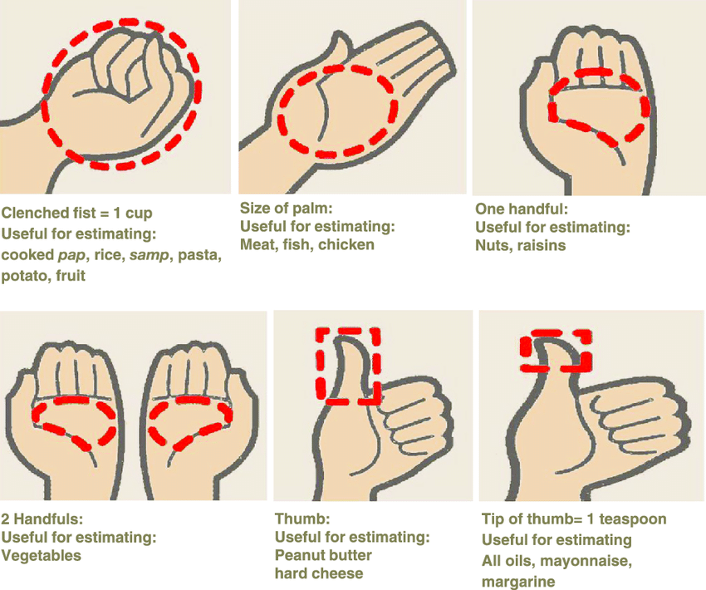
THREE Day Food Diary
Please include ALL food eaten and ALL drinks and include how much was eaten

DAY ONE
Date:Click or tap here to enter text. | Wake up time Click or tap here to enter text.
 | All food and drink | How much eaten | Where did you eat? (home, school, restaurant etc)
Breakfast  Time: Click or tap here to enter text. | Click or tap here to enter text. | Click or tap here to enter text. | Click or tap here to enter text.
Mid morning  Time: Click or tap here to enter text. | Click or tap here to enter text. | Click or tap here to enter text. | Click or tap here to enter text.
Lunch  Time:Click or tap here to enter text. | Click or tap here to enter text. | Click or tap here to enter text. | Click or tap here to enter text.
Afternoon  Time: Click or tap here to enter text. | Click or tap here to enter text. | Click or tap here to enter text. | Click or tap here to enter text.
Dinner  Time:Click or tap here to enter text. | Click or tap here to enter text. | Click or tap here to enter text. | Click or tap here to enter text.
Evening  Time: Click or tap here to enter text. | Click or tap here to enter text. | Click or tap here to enter text. | Click or tap here to enter text.
Night  Time: Click or tap here to enter text. | Click or tap here to enter text. | Click or tap here to enter text. | Click or tap here to enter text.
Additional comments for day One | Click or tap here to enter text.
DAY TWO
Date:Click or tap here to enter text. | Wake up time Click or tap here to enter text.
 | All food and drink | How much eaten | Where did you eat? (home, school, restaurant etc)
Breakfast  Time: Click or tap here to enter text. | Click or tap here to enter text. | Click or tap here to enter text. | Click or tap here to enter text.
Mid morning  Time: Click or tap here to enter text. | Click or tap here to enter text. | Click or tap here to enter text. | Click or tap here to enter text.
Lunch  Time:Click or tap here to enter text. | Click or tap here to enter text. | Click or tap here to enter text. | Click or tap here to enter text.
Afternoon  Time: Click or tap here to enter text. | Click or tap here to enter text. | Click or tap here to enter text. | Click or tap here to enter text.
Dinner  Time:Click or tap here to enter text. | Click or tap here to enter text. | Click or tap here to enter text. | Click or tap here to enter text.
Evening  Time: Click or tap here to enter text. | Click or tap here to enter text. | Click or tap here to enter text. | Click or tap here to enter text.
Night  Time: Click or tap here to enter text. | Click or tap here to enter text. | Click or tap here to enter text. | Click or tap here to enter text.
Additional comments for day Two | Click or tap here to enter text.
DAY THREE
Date: Click or tap here to enter text. | Wake up time Click or tap here to enter text.
 | All food and drink | How much eaten | Where did you eat? (home, school, restaurant etc)
Breakfast  Time: Click or tap here to enter text. | Click or tap here to enter text. | Click or tap here to enter text. | Click or tap here to enter text.
Mid morning  Time: Click or tap here to enter text. | Click or tap here to enter text. | Click or tap here to enter text. | Click or tap here to enter text.
Lunch  Time: Click or tap here to enter text. | Click or tap here to enter text. | Click or tap here to enter text. | Click or tap here to enter text.
Afternoon  Time: Click or tap here to enter text. | Click or tap here to enter text. | Click or tap here to enter text. | Click or tap here to enter text.
Dinner  Time: Click or tap here to enter text. | Click or tap here to enter text. | Click or tap here to enter text. | Click or tap here to enter text.
Evening  Time: Click or tap here to enter text. | Click or tap here to enter text. | Click or tap here to enter text. | Click or tap here to enter text.
Night  Time: Click or tap here to enter text. | Click or tap here to enter text. | Click or tap here to enter text. | Click or tap here to enter text.
Additional comments for day Three | Click or tap here to enter text.

Referrer Details (If not self referral)
Name of referrer | Click or tap here to enter text.
Relationship to patient: | Click or tap here to enter text.
Contact address: | Click or tap here to enter text.
Post code: | Click or tap here to enter text.
Telephone number: | Click or tap here to enter text.
Email address: | Click or tap here to enter text.
Patient has agreed to information in the food diary to be shared as part of the referral *note that referrals for the ARFID service require this information Yes ☐ No ☐

