Patient & Carer Consultative Committees Terms of Reference
January 2020
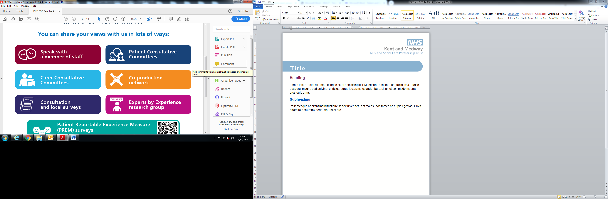
 | Patient & Carer Consultative Committees
Purpose of Committees | We invite service users and carers to get involved in various planning and monitoring activities across our services, often via the patient and carer consultative committees across Kent and Medway  Our patient consultative committee meetings are bi-monthly and held in the three regions of north Kent, east Kent and west Kent. These meetings provide an opportunity for service users and carers to feed back any ideas or concerns they have about service delivery and to engage with us about new service developments.  - East Kent patient consultative committee - this group covers Ashford, Canterbury, Margate, Broadstairs, Ramsgate, Dover, Folkestone, Sandwich, Deal, Hythe, New Romney, Whitstable, Herne Bay, Faversham and villages.  - West Kent patient consultative committee - this group covers Sevenoaks, Tunbridge Wells, Tonbridge, Maidstone, West Malling and villages.  - North Kent patient consultative committee - this covers Swanley, Dartford, Rochester, Gillingham, Chatham, Gravesend, Sittingbourne, Sheerness and villages.  We also host carer consultative committee meetings for carers in west and north Kent.  - West and north Kent carer consultative committee - this group covers Sevenoaks, Tunbridge Wells, Tonbridge, Maidstone, West Malling, Rochester, Gillingham, Chatham, Dartford, Gravesend, Swanley and villages.
Membership | - Patient Experience Manager (chairperson)  - Executive or Senior Kent and Medway NHS and Social Care Partnership Trust Staff (the Trust)  - Service user and Carers Groups commissioned for supporting service users and carers in the community  - Voluntary agencies  - Individual service users and carers  - Service representatives
Duties | - The committees will be made up of members. Non-members with an interest in local mental health issues may also attend Consultative Committee meetings as observers and at the discretion of the chairperson and membership  - All members will aim to promote the Consultative Committee locally  - Members will aim to provide a delegate if they cannot attend a meeting  - Those members who are linked to local service user and carer groups will also represent those groups at the Consultative Committees  - Members who are representatives will provide verbal or written reports on their group’s activities to the Consultative Committees  - Patient Experience Team in partnership with KMPT staff will help facilitate the Consultative Committee and provide administration support  - A service manager identified from within each service line will act as a link person to clinical staff. This function will be delegated to a team manager in the absence of the service manager  - The link person will be responsible for ensuring operational issues identified by the Consultative Committees are taken forward and responded to where appropriate  - The Committees will normally identify and request a guest speaker to be present at each meeting. This request will be coordinated by the link person  - The Committees will receive and consider feedback from the Trust Wide Patient & Carer Experience Group (TWP&CEG)  - The Committees will identify service improvement items that will be reported back to the bi monthly TWP&CEG
Quorum | The meeting will be deemed to be a quorum if four or more members are present
Frequency of meetings | Meetings shall normally be bi-monthly, no less than 6 meetings per year
Agenda / Notice of meetings | Meetings shall be organised by the Patient Experience Team. Notice of each meeting confirming the venue, time and date together with an agenda of items to be discussed, shall be forwarded to each member of the Committees no fewer than 5 working days prior to the date of the meeting.
Minutes of Meetings | Minutes of meetings will be produced and circulated to the membership. Formal reports from the group will be sent to appropriate groups for consideration and action as required. The minutes of consultative committees shall be formally recorded and published on the external website once approved.
Travel expenses | All service users and carers attending will be reimbursed.
Website | Patient and Carer Consultative Committees has a dedicated area on KMPT external website:  https://www.kmpt.nhs.uk/get-involved/service-user-and-carer/
Equal Opportunities | The Consultative Committees will seek to actively promote diversity and equal opportunities, and will not discriminate on any grounds.  The Consultative Committees will encourage equality of opportunity by actively encouraging wider participation and always attempt to develop representation of mental health service users, carers and ex-service users including from marginalised groups.
Reporting responsibilities | The Chair report three issues from each committee to the Trust Wide Patient and Carer Experience Group. The minutes of Patient & Carer Consultative Committees shall be formally recorded and published on the external website once approved.
Review | These Terms of Reference to be reviewed annually, to start one year after the date of ratification.

